Climate change evidence
Floating ice shelves
Ice shelves consist of glacial ice and are the floating extensions of grounded ice sheets. The Ronne-Filchner Ice Shelf in the Weddell Sea is by volume the largest ice shelf on Earth. Some estimates place the size of the ice shelf at ~420,000 square km.
Antarctica’s floating ice shelves cover 1.5 million square km in total – as large as the entire Greenland Ice Sheet, making up 11% of Antarctica’s total area.
Antarctica loses mass (ice) through calving of icebergs and through melting into the ocean.
Antarctica’s ice melt mostly occurs through the floating ice shelves, with half of the total Antarctic meltwater being produced through 10 small ice shelves along the Southeast Pacific.
The highest melt rates are from the northern end of George VI Ice Shelf to the western end of Getz Ice Shelf.
In recent years, the ice shelves around the Antarctic Peninsula, including Larsen A and B, have thinned, shrunk, and eventually completely disintegrated.
These ice shelves were destroyed by surface meltwater ponding on the ice shelf surface, melting through the ice, and eventually causing the ice shelf to break apart in one warm summer.

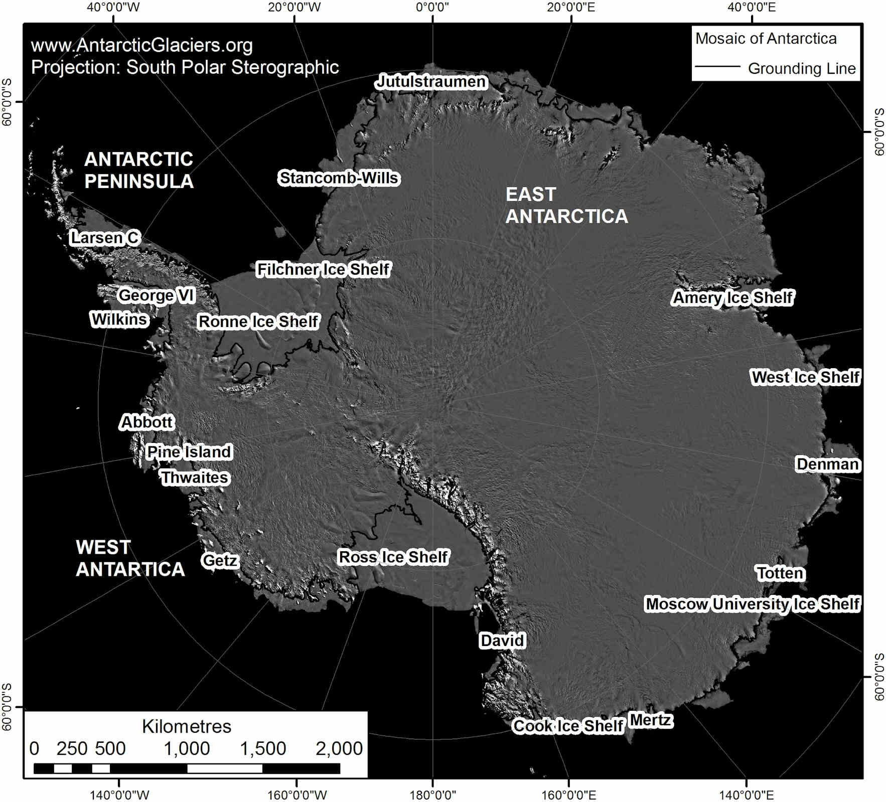
Ice shelves around Antarctica. Source: www.AntarcticGlaciers.org.

The glaciers that flowed into these ice shelves accelerated, thinned and retreated in response to the removal of the ice shelf, leading to increased discharge of ice into the ocean.
Here is a YouTube video showing the collapse of the Larsen B Ice Shelf, on the Antarctic Peninsula.

The GRACE satellites: tracking ice mass loss
The NASA GRACE satellites have been monitoring the variation in ice mass across Antarctica since 2002. The data is shown in the table on the next page. The satellites show how the portion of the Antarctic Ice Sheet that are on land is losing ice volume.
This mass loss is measured in Gigatonnes (Gt); 1 Gigatonne is 1 billion metric tonnes, and is equal to a cube of water that is 1 km high, 1 km wide and 1 km deep! It takes 361 Gt of ice to raise global sea levels by around 1mm.
The table on the next page (source: Ice sheets © NASA Vital Signs of the Planet) shows the cumulative mass loss in Antarctica, as measured by the Grace satellites. The gap in the dataset between 2016 and 2017 is due to time between missions.
This mass loss is not equal everywhere, but instead is focused in West Antarctica. From 1992 to 2017, the mass loss from West Antarctica has increased from 53 ± 29 Gt to 159 ± 26 Gt per year.
The acceleration of mass loss in West Antarctica is driven by a reduction in the floating ice shelves that surround the West Antarctic Ice Sheet.
The thinner ice shelves are unable to support the ice that flows into them, resulting in accelerating ice velocities and retreat of the glaciers.
Antarctic mass variation since 2002
Date | Gigatonne | Approximation range
Sept 2022 | 44.6 | ± 97
Sept 2003 | -129.60 | ± 40
Sept 2004 | -160.60 | ± 36
Sept 2005 | -111.90 | ± 34
Sept 2006 | -21.50 | ± 38
Sept 2007 | -158.50 | ± 39
Sept 2008 | -443.70 | ± 40
Sept 2009 | -482.20 | ± 34
Sept 2010 | -846.60 | ± 36
Sept 2011 | -840.90 | ± 40
Sept 2012 | -951.30 | ± 41
Jul 2013 | -1212.50 | ± 38
Sept 2014 | -1366.90 | ± 33
Sept 2015 | -1854.20 | ± 37
Aug 2016 | -1615.70 | ± 37
Sept 2017
Jul 2018 | -2037.70 | ± 31
Sept 2019 | -2331.80 | ± 27
Sept 2020 | -2468.80 | ± 27
Sept 2021 | -2697.40 | ± 27
Sept 2022 | -2358 | ± 47

Antarctic sea ice
Sea ice is frozen sea water. It is free-floating, and not attached to the land. Sea ice peaks in September each year (at around 18-20 million km²), and the end of the winter, and is at its smallest in February each year (2-4 million km²), at the end of the Antarctic summer.

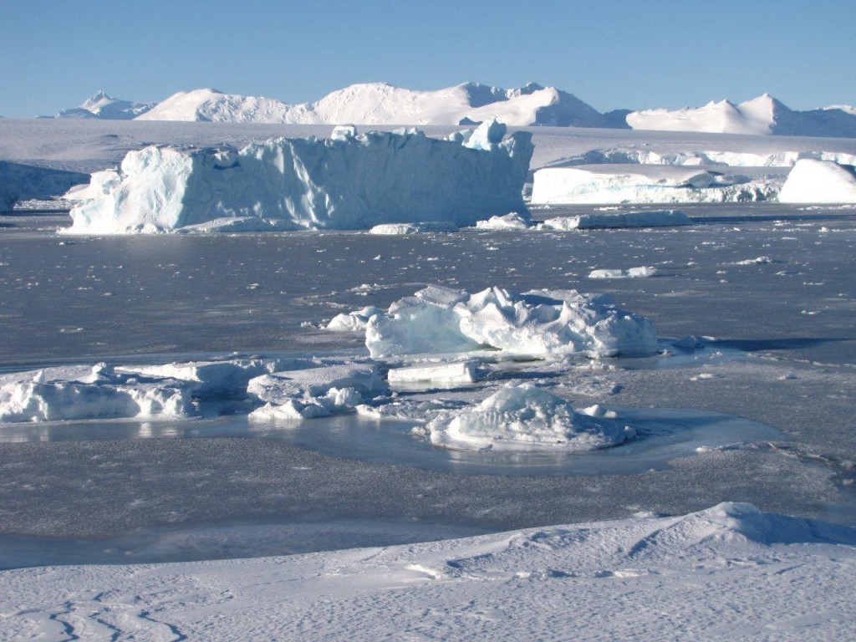
Icebergs frozen in sea ice, near Rothera Research Station, Antarctic Peninsula. Source: Bethan Davies (www.AntarcticGlaciers.org).

The amount of sea ice surrounding the Antarctic continent therefore varies a lot between the seasons. The ice shelves, in contrast, are much thicker, are attached to the land ice, and receive ice flowing into them from the land glaciers.
There is a lot of variation, year on year, in the extent of the sea ice in Antarctica. Scientists have been observing sea ice extent using satellites since 1978. Antarctic sea ice was slowly growing until 2014, in contrast with the strong losses of sea ice in the Arctic. Antarctic sea ice reached a record high in winter 2014.

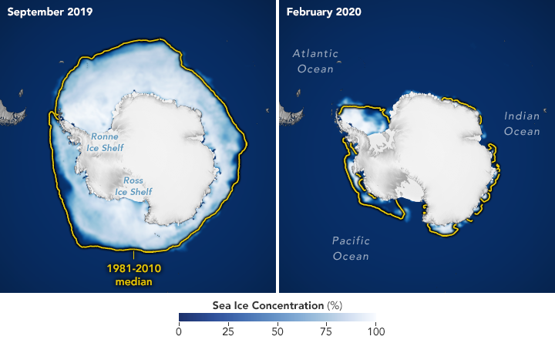
Antarctica sea ice peaks in September each year, marking the end of the Southern Hemisphere winter. Source: NASA Earth Observatory. https://earthobservatory.nasa.gov/world-of-change/sea-ice-antarctic

Since then, Antarctic sea ice has been shrinking, reaching a record low in 2017. From 2017-2023, the four lowest annual minimum sea-ice extents have been recorded, with 2022 and 2023 both setting new records for minimum extent, below 2 million km². Sea ice remained at near record lows in the winter as well.
More analysis is needed before scientists can confidently understand the reasons for, and impacts of, these changes.

Antarctic heat waves
Antarctica is very cold, largely below 0°C. However, there have been heat waves in Antarctica. In March 2022, an extreme heat wave in East Antarctica caused surface temperatures 38.5°C above the usual temperature for that time of year.
Heat waves have also been recorded on the Antarctic Peninsula, with one in February 2020 attributed to fossil-fuel burning.
This heat wave was associated with an ‘atmospheric river’: a long, thin atmospheric structure that carries warm moist air hundreds of kilometers, leading to localised heat and precipitation. These atmospheric rivers transport heat from the tropics to Antarctica.
These heat waves can drive big impacts. For example, they can cause calving of large icebergs from the floating ice shelves, or cause more surface meltwater to form on ice shelves.


A resource produced by Dr. Bethan Davies, Senior Lecturer at Newcastle University

