The world upside down?
From Antarctica, the rest of the world looks a very different shape!
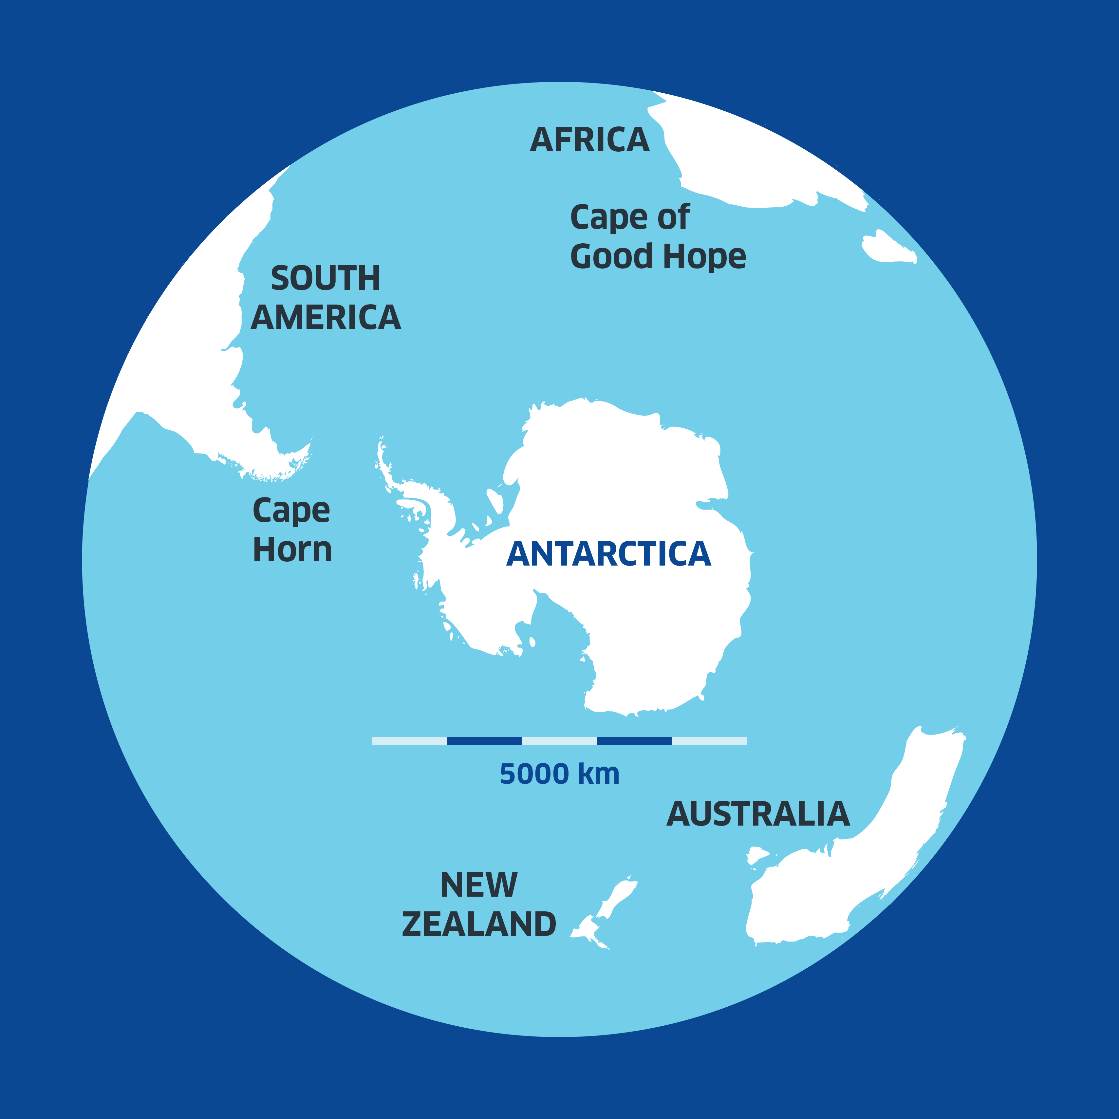
Questions
- Using the first map, what is the closest continent to Antarctica?

- Using the scale bar, what is the distance from Antarctica to:

- Cape of Good Hope
- Cape Horn

- In which compass direction (North, South, East, West) do you move from Antarctica to get to:
- South America?
- Australia?

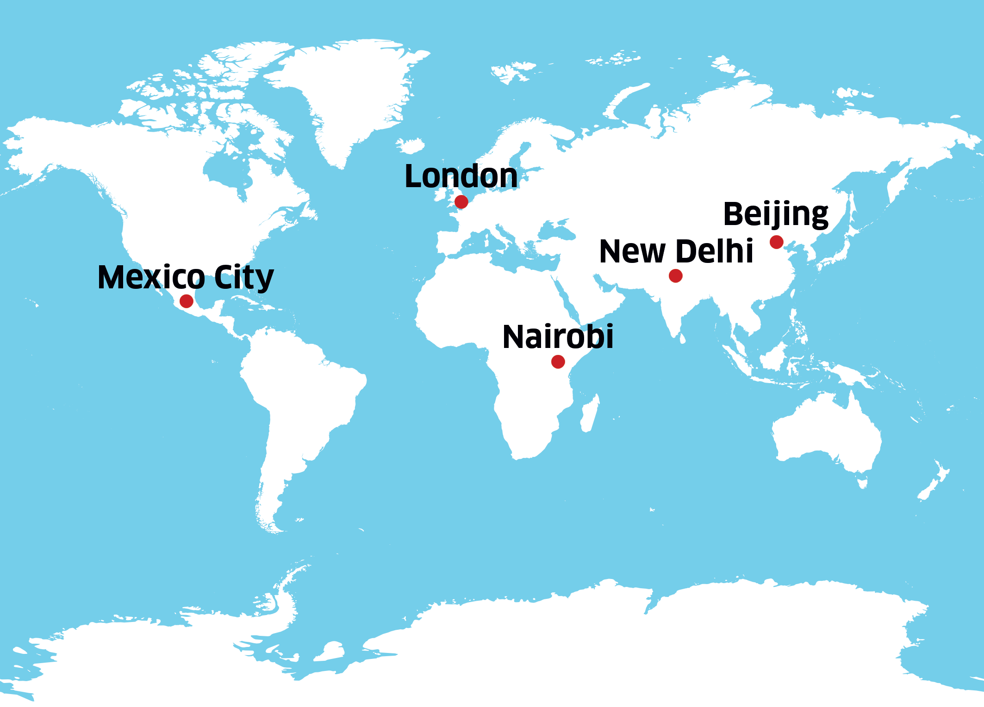

- By looking at the map above, place in order which global cities you think are closest to Antarctica (1 being the closest, 5 being the furthest)
- London, UK
- New Delhi, India
- Mexico City, Mexico
- Nairobi, Kenya
- Beijing, China

Answers
- The nearest continent to Antarctica is
South America.

- a) From the Cape of Good Hope the distance is about 5,000 km.

- From Cape Horn the distance is about 4,000 km.

- It doesn’t matter where you go, travel away from Antarctica is always to the North! A trick question!

- Nairobi, Mexico City, New Delhi, Beijing, UK

