Antarctica: The frozen continent
Here we are going to be summarising what we have learnt so far and learn some new information to help us become experts on Antarctica!
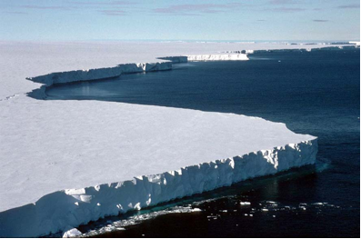
Antarctica is the world’s last great wilderness.
Antarctica is almost entirely covered by ice, with only 2% of its surface presenting bare rock. Because of its hostile environment, Antarctica has no permanent habitats and therefore makes it is the least habited, and the least polluted continent on Earth.
Antarctica covers almost 9% of the Earth’s surface, and is 25% larger than the whole of Europe combined, making it the fifth largest continent!
We have previously learnt that Antarctica can be divided up into different ice sheets. The two largest are the West Antarctic Ice Sheet, and East Antarctic Ice Sheet.
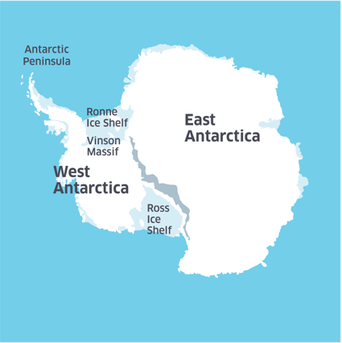

Both the East and the West Ice Sheets are divided up by a long mountain chain, known as the Transantarctic Mountains, shown in the figure above with the darker grey line. These mountains stretch 3,540 kilometres across the continent
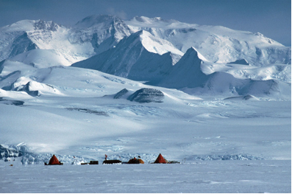
Antarctica is the largest single mass of ice on Earth. At least 3 million years old, and possibly as much as 30 million years old in places.
The ice sheet averages 2,450 metres deep and holds about 70% of the world’s fresh water. With such a thick layer of ice, Antarctica is the highest of all the continents.
The average altitude is about 2,300 metres above sea level, although in places, the bottom of the ice can be as much as 2,500m below sea level. If they weren’t filled with ice, large parts of Antarctica would be under the sea. Vinson Massif is Antarctica’s highest point, rising to a height of 4,897 metres.
Antarctica’s ice sheet is constantly on the move. Huge rivers of ice known as glaciers are pulled slowly by gravity from the middle of the continent towards the sea. Along the way, the ice cracks, breaks and is ruptured by underlying rock. Crevasses up to hundreds of metres deep can form on the surface.
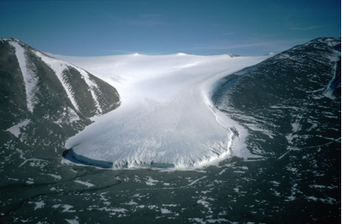

On reaching the sea, the glaciers spill out over the water’s surface and create gigantic floating blocks of ice called ice shelves. The largest, the Ross Ice Shelf (labelled in Figure 1), is the size of France. Sometimes pieces of an ice shelf break off to form icebergs. Beyond the ice shelves, much of the surrounding ocean freezes over during the winter. With this extra winter sea ice, Antarctica almost doubles in size.

