Sizing up Antarctica
Guess it:
Look at the maps below – have a guess at approximately how many countries the size of the UK would fit into Antarctica … is it:
About 40? About 60? About 80? About 100?
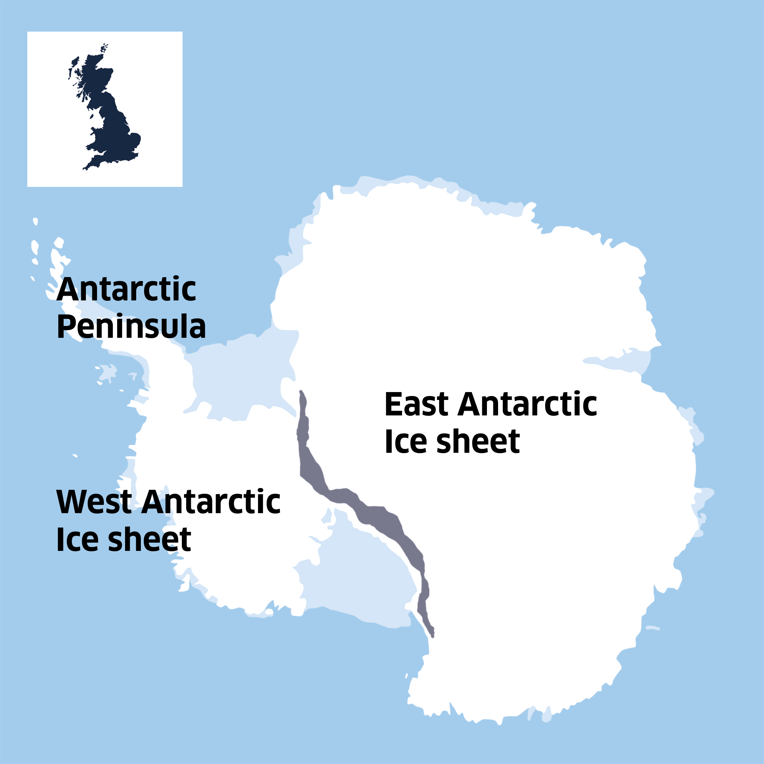

Check it:
Total land area (square kilometres)
- Antarctica 13,829,430 km2
- UK 224,820 km2
To calculate how many countries the size of the UK would approximately fit into Antarctica divide Antarctica’s land area by the UK’s land area.
Were you close?
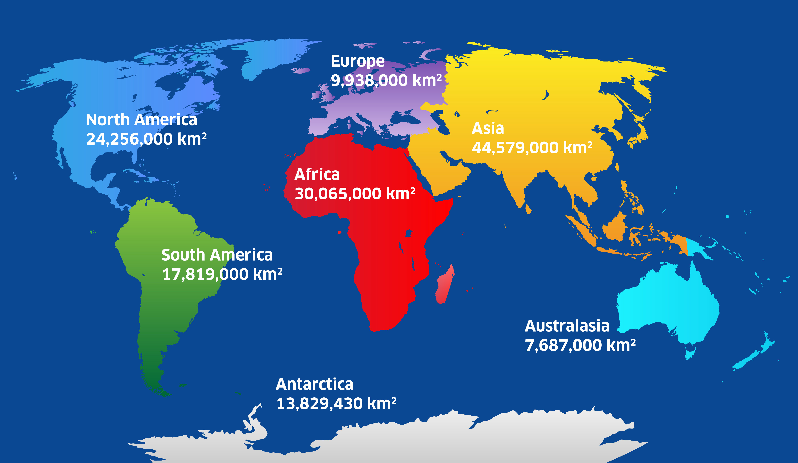
Compare it:

Using the world map above, how does Antarctica compare in size to the world’s other continents? Can you place in order the different continents from 1 being the smallest, to 7 being the largest?
What place does Antarctica come?

Different Ice Sheets
Antarctica is a continent formed of three difference ice sheets, this is shown in Figure 1. The Antarctic Peninsula which is the mountainous spine Northwest of Figure 1 and the smallest, the West Antarctic Ice Sheet which is on the western side of the continent, and then the East Antarctic Ice Sheet on the east and is the largest ice sheet of them all. You can compare their sizes below.

Ice Sheet | Size
Antarctic Peninsula | 522,000 km²
West Antarctic Ice Sheet | 1,970,000 km²
East Antarctic Ice Sheet | 10,200,000 km²

