The climate of the past
Ice cores drilled from Antarctica’s surface can provide scientists with information about what the climate and atmosphere was like hundreds of thousands of years ago.

Looking at the figure of temperature and CO₂ from Antarctica’s ice core below, you can see that over time the climate has gone through cool stages (shown in blue) and warm stages (shown in the darker red colours). These switches from cooler to warmer stages are known as glacial (cold) and interglacial (warm) periods.

Temperature is not the only thing changing over time, atmospheric greenhouse gasses, particularly carbon dioxide is also changing. You may notice that the temperature closely follows the trends in CO₂, demonstrating that the amount of CO₂ found in the atmosphere has a direct effect on the temperatures.

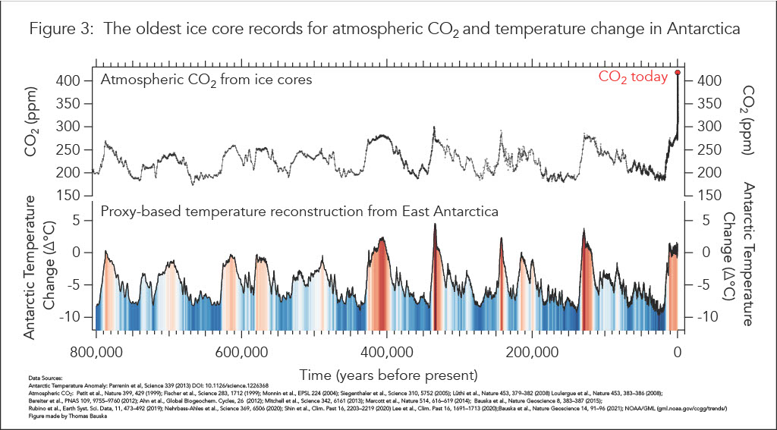

Now let’s take a trip back in time to look closer at certain parts of the Earth’s climate and environmental history which has been recorded in the Antarctic ice cores.

900,000 years ago
From one of the deepest ice core samples ever extracted, scientists have confirmed that in the last 900,000 years, Earth has been through eight separate Ice Ages (or glacial periods shown in blue), when the climate was much colder than today.

73,000 years ago
Antarctica’s ice cores are also very good at recording dust and ash particles. About 73,000 years ago Antarctica’s ice core showed evidence of a huge volcanic eruption from Indonesia. The dust and ash particles got so high that some even landed on Antarctica’s surface and are now locked up in the ice core records.

12,000 years ago
About 12,000 years ago the ice cores recorded a very rapid change to cooler temperatures. The ice cores showed that these temperature decreases happened over only a few hundred years showing that climate changes were much faster than previously thought.

1400s
Temperature is not the only climate variable that Antarctica’s ice cores can record. They can also record changes to windiness and storminess. In the 1400s there was a spike in the sodium recorded in the ice which was marking at time when the seas surrounding Antarctica were stormier and were throwing up salt onto the ice.

1800s
Higher concentrations of carbon dioxide and nitrous oxides trapped in the ice mark the beginning of the Industrial Revolution and the burning of fossil fuels in power stations, factories, and cars.

1960s
Ice layers show a drop in the concentrations of radioactive gases in the ice following the ban on testing atomic bombs in 1963.

2000
After an all-time high in the 1980s, samples of ice from recent years show a drop in lead concentrations in the ice. This shows the impact of the worldwide introduction of lead-free petrol.

Today
By measuring carbon dioxide concentrations trapped in the ice, scientists now know carbon dioxide concentrations today are the highest for 650,000 years. Scientists have linked these higher concentrations with higher temperatures, suggesting global warming.

Ask yourself these questions about what we can learn from the ice:

- Look at the graph, what do you notice about the climate? Are we in a glacial or interglacial period?

- By looking at the graphs, how long roughly does a glacial period (blue) and interglacial (red) period last?

- Look at the carbon dioxide graph, you will see that carbon dioxide today is much higher than in the past. What do you think this will do the temperatures in the future?

- In what ways have people changed the air quality over time?

