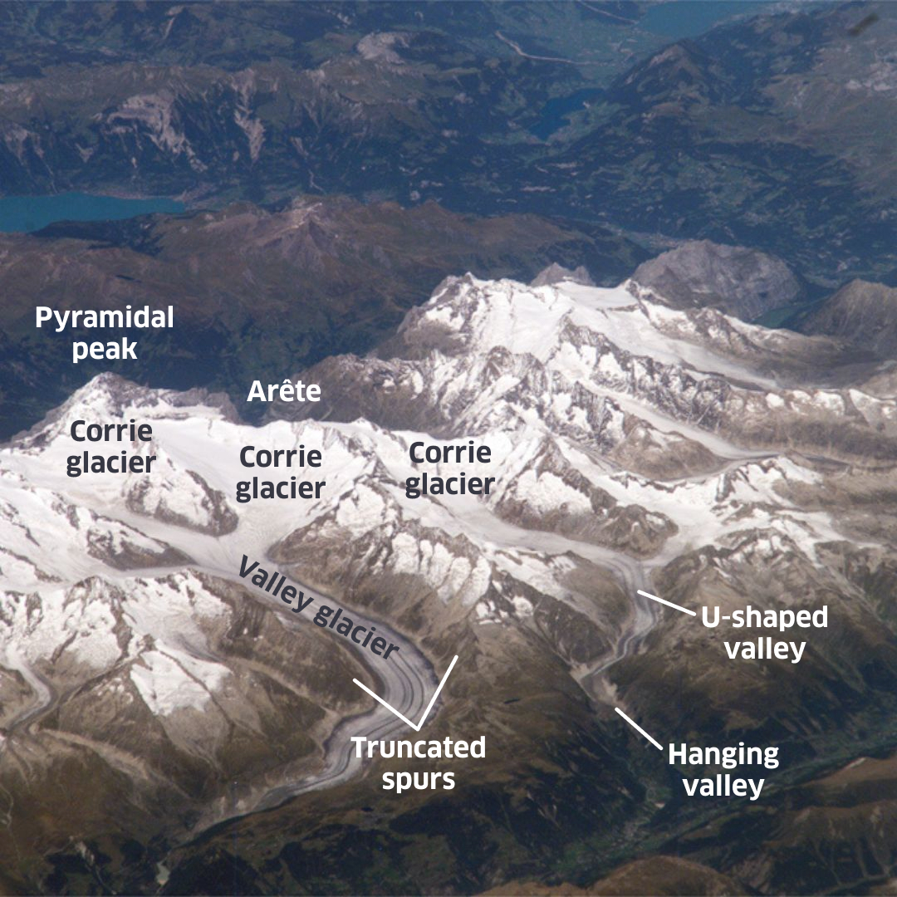
Ice Sheets and Glaciation answers

