The climate of Antarctica today
The climate of Antarctica is unlike anywhere else on Earth with its constant freezing temperatures and its very windy conditions.
Some scientists who work on in Antarctica, like those at the Rothera Research Station have to work all year round and experience the harsh conditions through the changing seasons.

The table below displays the both average monthly temperatures and wind speed at Rothera Research Station and in London.

Look at the data and the graph and answer the questions on the following pages

Rothera research station | Jan | Feb | Mar | Apr | May | Jun | Jul | Aug | Sep | Oct | Nov | Dec
Temperature (°C) | 1.4 | 0.7 | -1.1 | -3.1 | -5 | -8.3 | -10.7 | -10.2 | -8.3 | -5.7 | 2.4 | 0.3
Windspeed (km/hr) | 16.7 | 22.2 | 25.9 | 22.2 | 20.4 | 14.8 | 22.2 | 27.8 | 20.4 | 29.7 | 18.5 | 22.2
City of London | Jan | Feb | Mar | Apr | May | Jun | Jul | Aug | Sep | Oct | Nov | Dec
Temperature (°C) | 7.6 | 7.8 | 8.2 | 10.7 | 13.8 | 16.1 | 18.9 | 18.7 | 15.9 | 12.5 | 8.8 | 6.31
Windspeed (km/hr) | 8.94 | 8.67 | 8.44 | 7.80 | 7.60 | 7.16 | 6.95 | 6.82 | 6.84 | 7.62 | 7.71 | 8.36

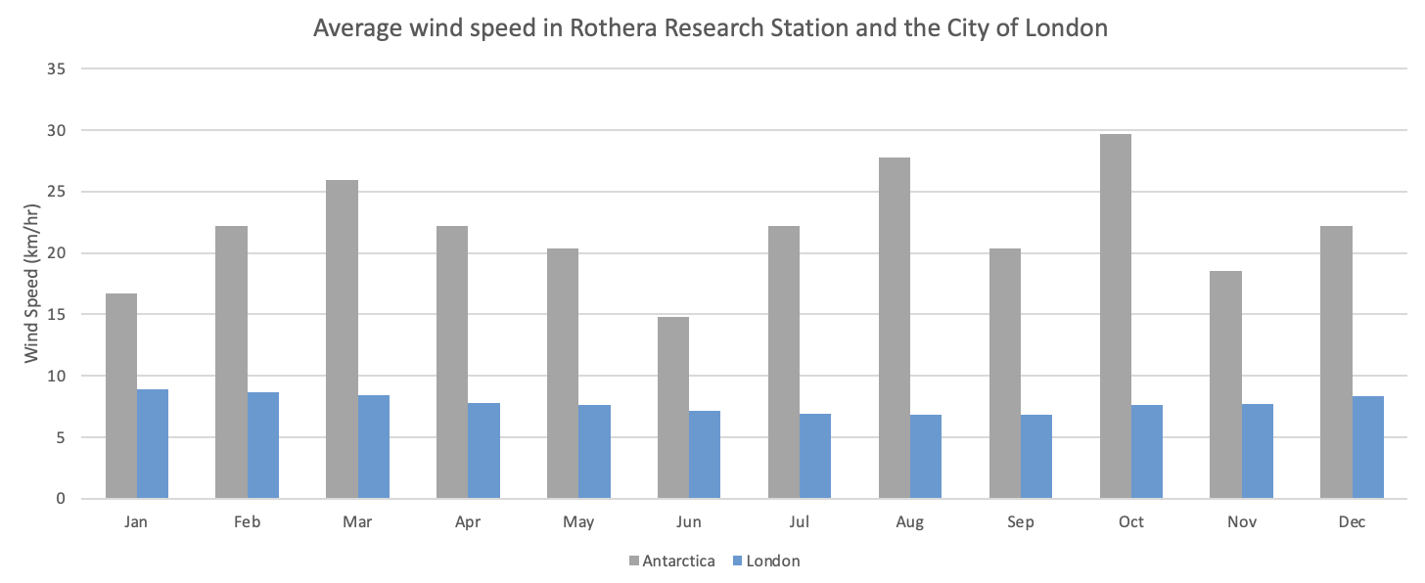
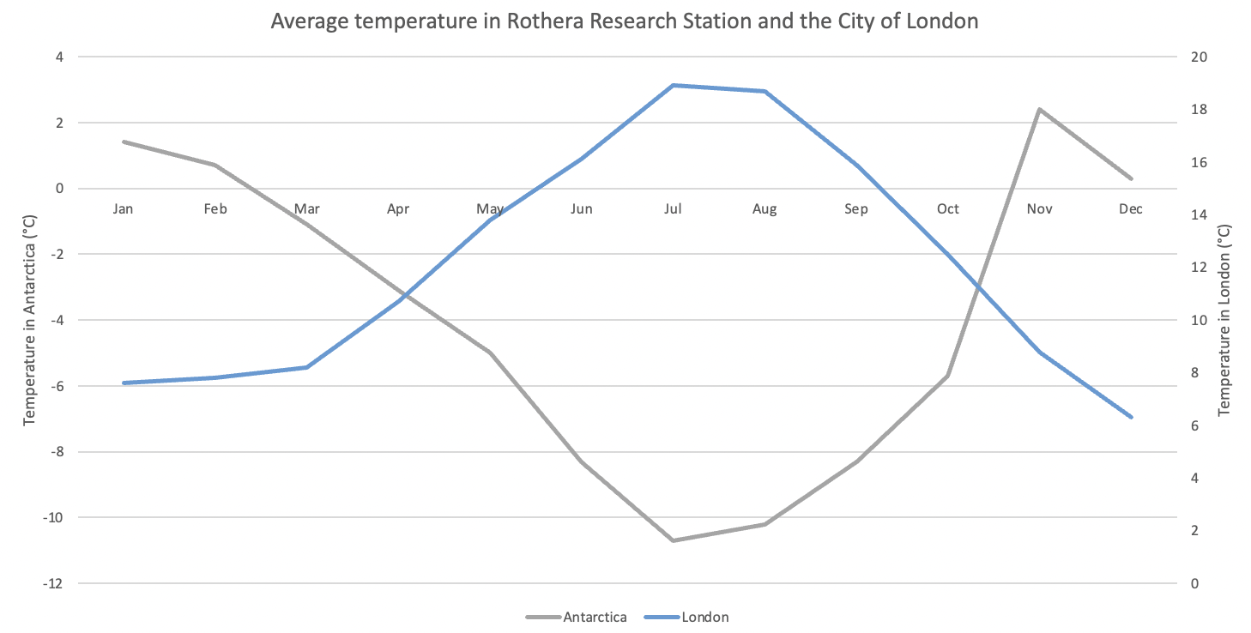
The average temperature and wind speed in Antarctica are much different to those in London.

1. What month is the warmest in both Antarctica and London?

2. Can you describe the annual wind pattern at Rothera Research Station?

3. Using the table above can you calculate the maximum range of temperatures in both Antarctica and London?
It’s the shortest and darkest day of the year. Tonight, the twenty of us still here are going to celebrate the winter solstice with a big party. Skiing on the sea-ice has been fun too - it is the closest thing to walking on water!

Days are now shorter, temperatures lower, snowfall heavier and most of the wildlife has left for warmer climes.
The weather is superb. Just imagine being here, sitting on the veranda, sun cream and sunglasses on, watching seal pups playing together - how lucky are we!

The solar panels and weather stations outside bang and clatter in the severe gales, so I haven’t got much sleep lately. Diving beneath the ice is one way to escape the wind, but once we’re back on the surface it doesn't take long for the bitter cold to freeze-mould our dry suits to our bodies.

Using the Rothera climate data, can you look at the diary extracts below and decide which month of the year these diary extracts came from?

There may be no trees here for leaves to fall off, but it’s getting colder and we are one step closer to winter. Those leaving soon are talking about the things they are going to do when they get home - have a pint of draught Guinness or go on holiday to a very hot, sunny place!

