Who killed the Krill?
Suspect Profile: Sid Squid

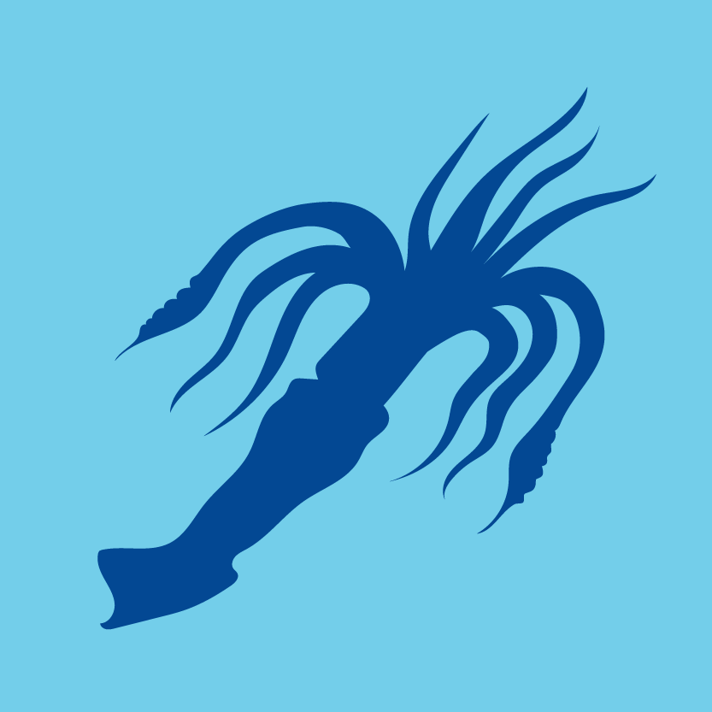
Did you know that collectively all your relatives in the world’s oceans would weigh more than all the people on land? There are twenty types of you living around Antarctica. Even here, together you would weigh about 100 million tons!
Most of you have ten tentacles which have strong jaws known as a beak in the middle. With these, you can catch krill, small fish, or even some of your smaller cousins!
But after krill you are the second most popular choice on the menu. Even though most of you have only got a year to live, a third of you are snapped up by whales, seals and seabirds. More of you meet their maker on the end of a fishing line or caught in a net.
And like other marine creatures you have lost large numbers of family members in recent years as the water has been too warm. Many of your baby larvae have died in their nursery grounds north of Antarctica as ocean temperatures have increased by about 1.50C.
Some of your relatives are seriously huge. One young female was washed up near Signy Island, a subantarctic island in the Scotia Sea. She was only young but was still over two metres long and that’s not even including the tentacles! Some people guess that a fully grown ‘colossal’ squid could be about 18 metres long!
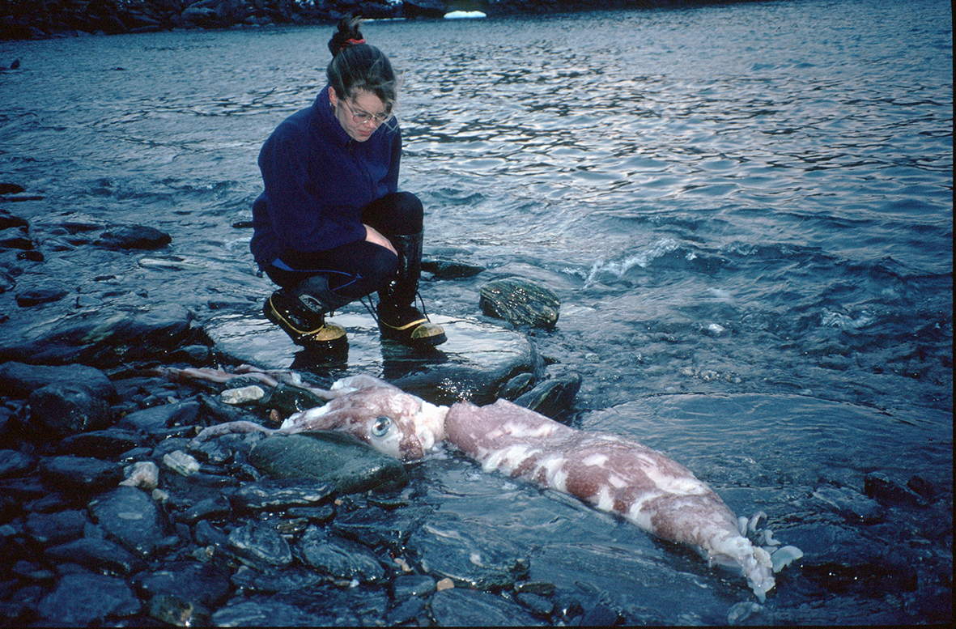
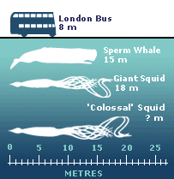

Go to the next page to read more about the victim.
Victim Profile: Krill
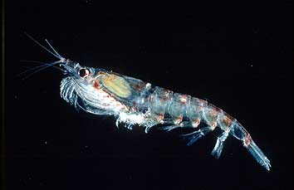
Krill is a Norwegian word for 'whale food' to describe the pink, see-through animals that live in the waters surrounding the Antarctic Peninsula. Antarctic krill live for up to 6 years and grow to about 6cm long. They gather in dense swarms up to hundreds of metres across. Each swarm contains millions of krill, turning areas of the ocean's surface pink.
In winter, krill live beneath the sea-ice where they can grow in safety. Here, they feed on algae and tiny plants called phytoplankton found under the surface of the sea-ice. In summer, krill spend their days in the dark depths of the ocean safe from their predators. At night time, they swim to the surface to feed.

For a more detailed profile on krill, visit
https://www.bas.ac.uk/about/antarctica/wildlife/krill/
http://www.theguardian.com/environment/2005/oct/19/frontpagenews.climatechange

