Sizing up Antarctica
Guess it:
Look at the maps below – have a guess at approximately how many countries the size of the UK would fit into Antarctica … is it:
About 40? About 60? About 80? About 100?
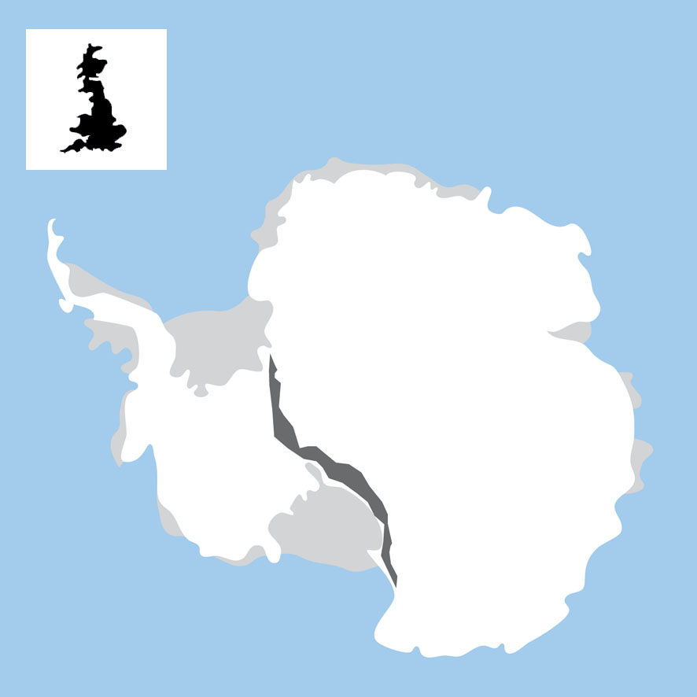

Check it:
Total land area (square kilometres)
- Antarctica 13,829,430 km2
- UK 224,820 km2
Now calculate about how many countries the size of the UK would fit into Antarctica.
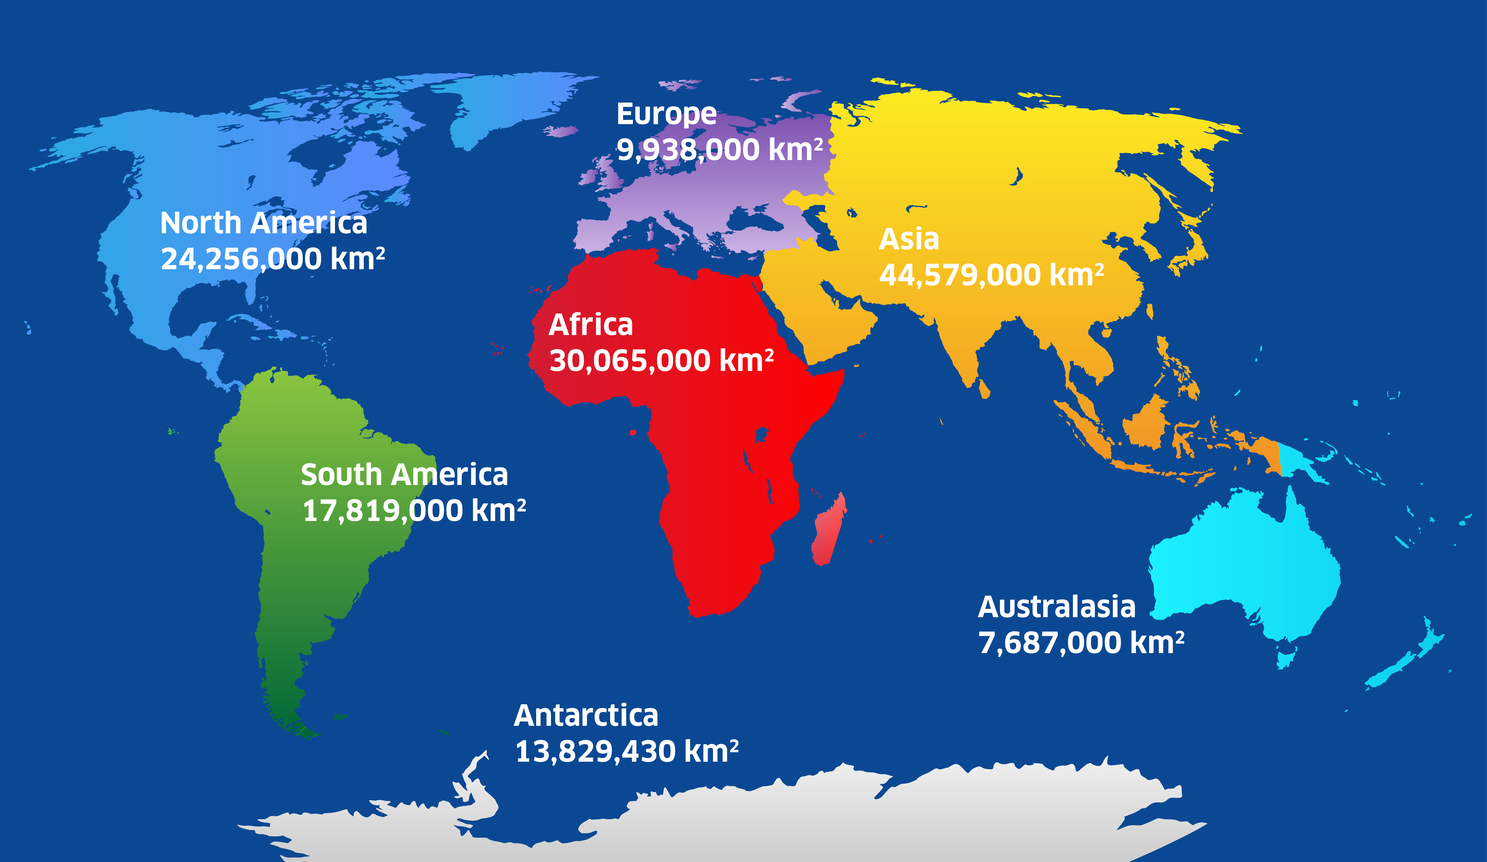
Compare it:

How does Antarctica compare in size to the world’s other continents? Antarctica is about half the size of Africa, but about twice the size as Australasia!
Re-order the continents from the biggest (number 1) to the smallest (number 7). Where does Antarctica come?
What time is it?
The time of day for nearly everywhere else in the world is set by its line of longitude. But the lines of longitude join together at the South Pole. An Antarctic research station usually sets its clock according to the time back in its home country.

Country | Research station | Time
UK | Rothera | 9 am
South Korea | King Sejong | 6 pm
Australia | Mawson | 7 pm
India | Maitri | 3 pm
USA | McMurdo | 4 am

Kevin is a scientist working at the British research station, Rothera. To compare his research findings he needs to phone other scientists at King Sejong, Mawson and Maitri research stations. If Kevin calls at 9 am, at which station:

- Might the scientists be having breakfast?
- Might the scientists be thinking about lunch?
- Might the scientists be thinking about dinner?

Sally is another scientist working at Rothera. She’s best friends with Duane, an American working at the McMurdo research station. They both have to work in their laboratories all day – why might they find it difficult to communicate?

