Developing Understanding Timeline

Part two - 1901 – 1942
It is difficult to make a complete and detailed timeline of the major Antarctic expeditions as there have been over 300 of these since Antarctica was sighted for the first time. More details of the journeys below and some of the others can be found at www.south-pole.com.

- What was the main purpose of each expedition - exploration, research or both?
- Have the objectives of these visits changed over time?

Use the information on this sheet and parts 1 and 3 to answer the questions above. You could present your findings in the form of a table.

1901 – 1904
Captain Robert Falcon Scott led the National Antarctic Expedition which was partly funded by the Royal Geographical Society under its President Sir Clement Markham. Markham and the RGS declared it ‘an opportunity for research and advancement in scientific knowledge concerning magnetism, meteorology, biology and geology’. It sailed in the specially built Discovery and achieved many ‘firsts’ such as the first aerial reconnaissance by means of a balloon, a journey to Cape Crozier, the ascent of the Polar Plateau and a record journey south by Scott, Shackleton and Wilson. They covered 5,000 km until illness and snow blindness forced them back. The collections went to the British Museum of Natural History, their statistical material to the Royal Society and their journal ‘South Polar Times’ written by the men during the long winters to the RGS.
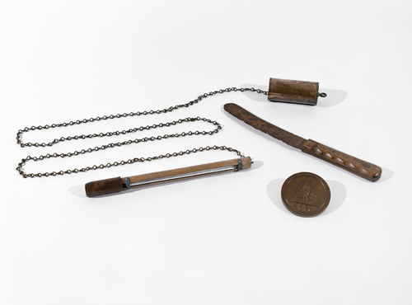
Ice thermometer, knife and medal
© Royal Geographical Society
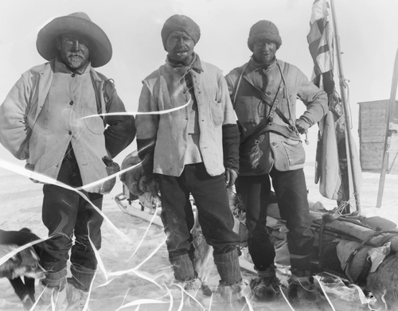
Sledge party © Royal Geographical Society

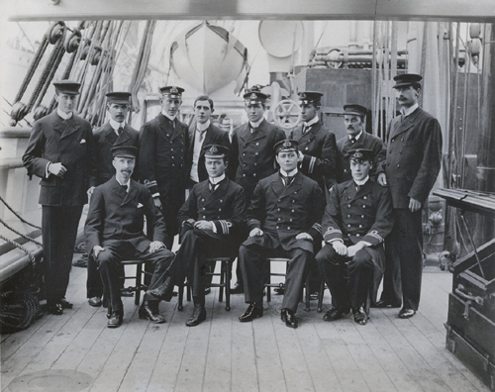
Party before departure on board the Discovery
© Royal Geographical Society

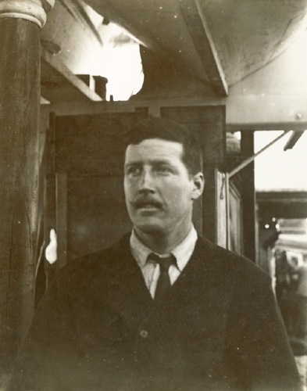
H.T. Ferrar, glaciologist on the 1901 – 1904 National Antarctic Expedition
© Royal Geographical Society

A transcript of part of a 1993 video of Evelyn Forbes, daughter of Hartley Travers Ferrar the expedition geologist, talking about working with Captain Scott.
‘Reading between the lines he found it very difficult working with Scott because he himself was not used to naval discipline and of course having been brought up wild and free in South Africa and being Irish he must have been extremely trying. He found himself with Shackleton and they got on very well together. He always said Shackleton was a tremendous leader, but at the same time he didn’t compare him with Scott, because he was extremely loyal, they all were. As has been said before the Heroic Age, when there was this little band of Antarctic men who were all extremely loyal to each other.’
SPRI Oral History Project

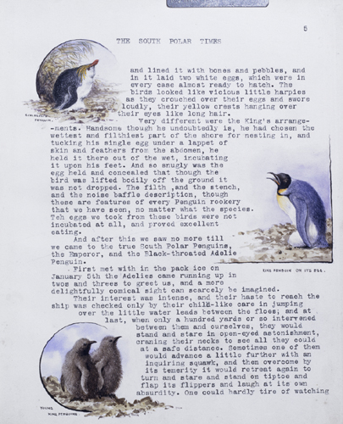
Some notes on penguins, South Polar Times
© Royal Geographical Society
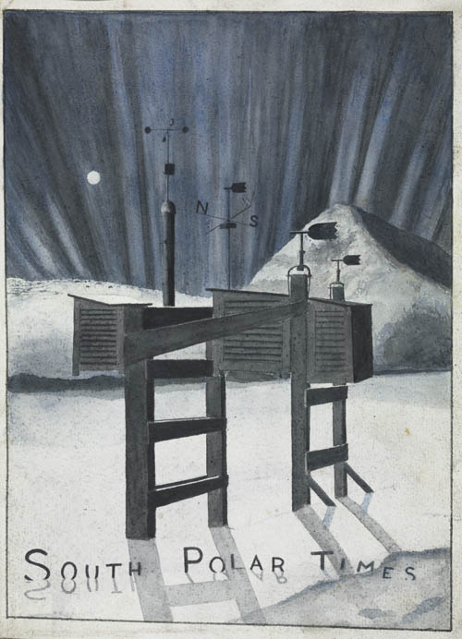
Cover of the south Polar Times
© Royal Geographical Society
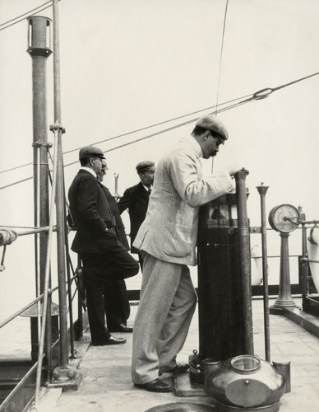
Using a compass on board the Discovery
© Royal Geographical Society
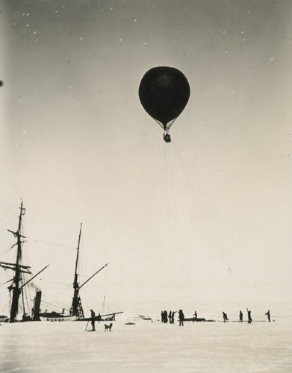
Balloon ascent, 1902
© Royal Geographical Society.

A transcript of part of a 1993 video of Evelyn Forbes, daughter of Hartley Travers Ferrar the expedition geologist, talking about finding gold.

‘He discovered gold, and brought home to his mother a tiny piece of gold bearing rock. She had it mounted and had a tiny, tiny geological hammer made, only about an inch and a half, with this little piece of rock mounted on the hammer with the longitude and latitude. My mother always wore it.’
SPRI Oral History Project

A transcript of part of a 1993 video of Evelyn Forbes, daughter of Hartley Travers Ferrar the expedition geologist, talking about laying the foundations of Antarctic geology.

‘I think it was in one of the Polar Records that he is referred to as “laying the foundations of Antarctic geology”, because of course he was the first there…” he was a lucky devil to have been there first in the field”
SPRI Oral History Project

1902
Otto Nordenskjold a Swedish geologist and five other men undertook the first exploration by sledge. They covered 650 kilometres in the area of Paulet Island and made a winter camp at Snow Hill south of Seymour Island. In the meantime their ship was crushed and they were forced to spend two winters in Antarctica until they were rescued by an Argentinean ship.

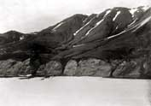
Snow Hill ©Royal Geographical Society

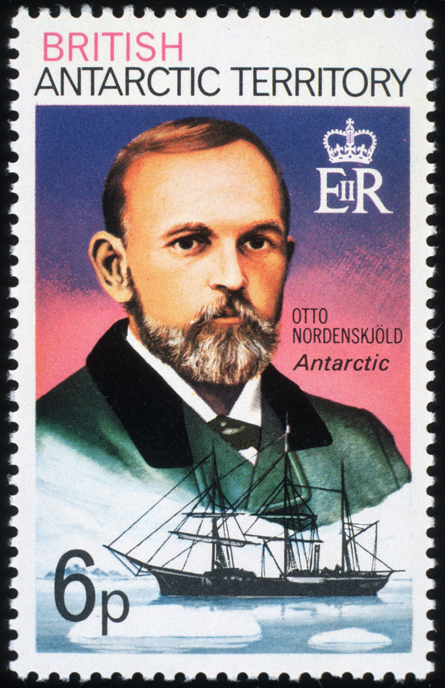
Antarctic Territory Stamp of Otto Nordenskjold with the ship Antarctica
© British Antarctic Survey, Chris Gilbert

1902 – 1904
Dr William Spiers Bruce led the Scottish Antarctic Expedition on board the Scotia under the command of Captain Thomas Robertson. The expedition was supported and promoted by the Royal Scottish Geographical Society and funded by the Coats brothers of a Paisley textile firm.

The primary objective of the expedition was to do extensive hydrographic work in the Weddell Sea during the summer of 1903 and 1904 and to survey the South Orkney Islands and study their wildlife. Despite being stuck in the ice for long periods the expedition discovered Coats Land and the first permanent meteorological station was set up on Laurie Island in the South Orkney Islands.
1903 – 1905
Dr Jean Baptiste Charcot on board the Francais led the first French Antarctic Expedition which surveyed the western side of the Antarctic Peninsula. The small expedition wintered in the ship in an inlet on Booth Island. Over two summers they discovered various locations including Port Lockroy. They charted the Biscoe Islands and generally extended Gerlache's survey of the western side of the Antarctic Peninsula.
1907 - 09
Ernest Shackleton Ernest Shackleton led the British Antarctic Expedition on the Nimrod to try to reach the South Pole, this time accompanied by Frank Wild, Eric Marshall and Jameson Adams. Although they got further than Scott’s team illness and hunger forced them to give up just 180 km from their destination where they planted a Union Jack and a canister to mark the point. Work on meteorological observations continued as did studies of penguins and seals. Members of the party were also the first to climb Mount Erebus and to reach the South Magnetic Pole.

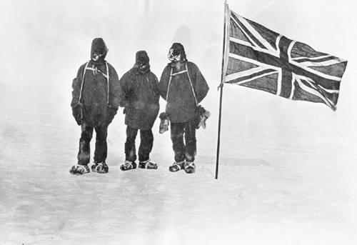
1909, at the South Magnetic Pole
© Royal Geographical Society

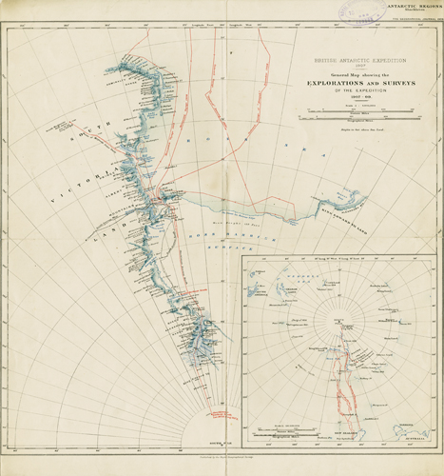
Map of the voyage of the Nimrod© Royal Geographical Society
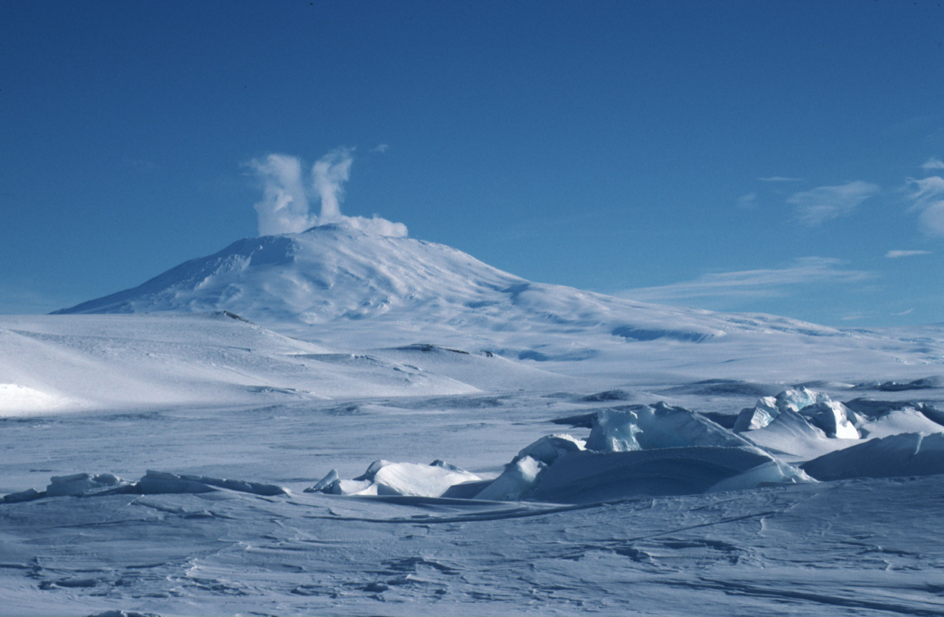
The crater of Mount Erebus
© Royal Geographical Society

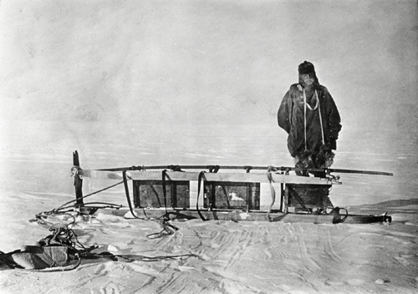
Shackleton with a sledge
© Royal Geographical Society
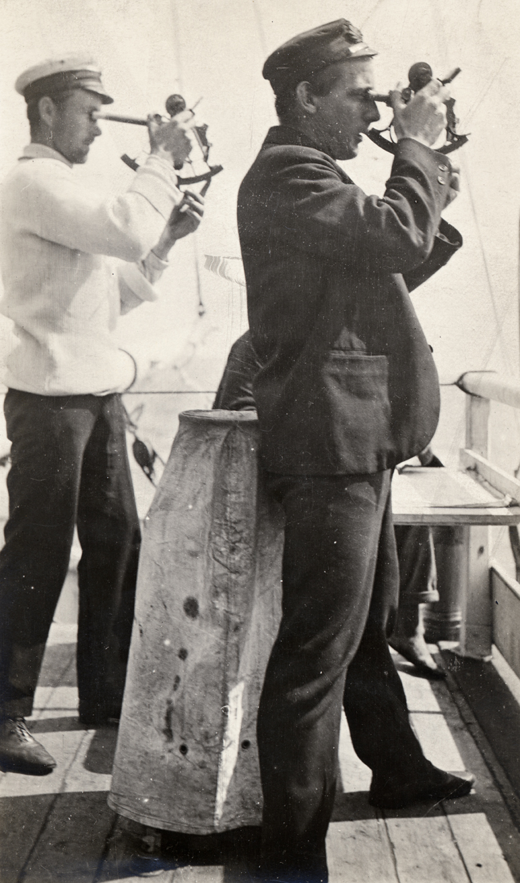
Using a sextant © Royal Geographical Society.

1908 – 1910
Dr Jean Baptiste Charcot led the second French Antarctic Expedition on board the Pourquoi – Pas? to continue the work begun in the previous expedition. Further detailed surveys were made of over 1250 miles of coastline and newly discovered lands. Enough scientific data was collected to fill over 28 volumes.
1910 – 1912
Norwegian Roald Amundsen and four other men were the first to reach the South Pole on 12 December 2011 thanks to a new route that only took them 57 days. Amundsen planted a Norwegian flag and wrote two letters – one for the king of Norway, and one for the British Antarctic Expedition team led by Robert F. Scott. The prime objective of their expedition was to reach the South Pole first, they did little scientific experimentation.
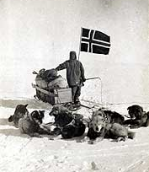
© Royal Geographical Society.

1910 – 13
Captain Robert Falcon Scott led the British Antarctic Expedition aboard the Terra Nova with the aim of reaching the South Pole as a major and public objective. There was also of an extensive programme of scientific experiments and explorations. The expedition was led by Captain Scott and included a scientific staff of twelve.
From the base camp hut set up at Cape Evans on Ross Island, the scientific staff carried out investigations in a wide range of fields, including meteorology building on the research of the 1901 – 1904 National Antarctic Expedition. One scientific journey in search of birds, to Cape Crozier was undertaken during the Antarctic winter and is described in the book ‘The Worst Journey in the World’ by Cherry Garrard. The men used green-tinted goggles to combat snow-blindness, skis and a mixture of ponies, dogs, motor sledges and man-hauling to reach the Pole. The party made up of Scott, Wilson, Bowers, Oates and Evans reached the South Pole on 17 January 1912, 33 days after Amundsen’s party.
Bad weather made the return from the Pole increasingly difficult and Scott and his party died frozen to death, only 18 km from a supply camp which might have saved them. Maps, geological specimens, photographs and diaries were collected from the camp by a search party in the following spring. More about the expedition can be found at http://www.unlockingthearchives.rgs.org/
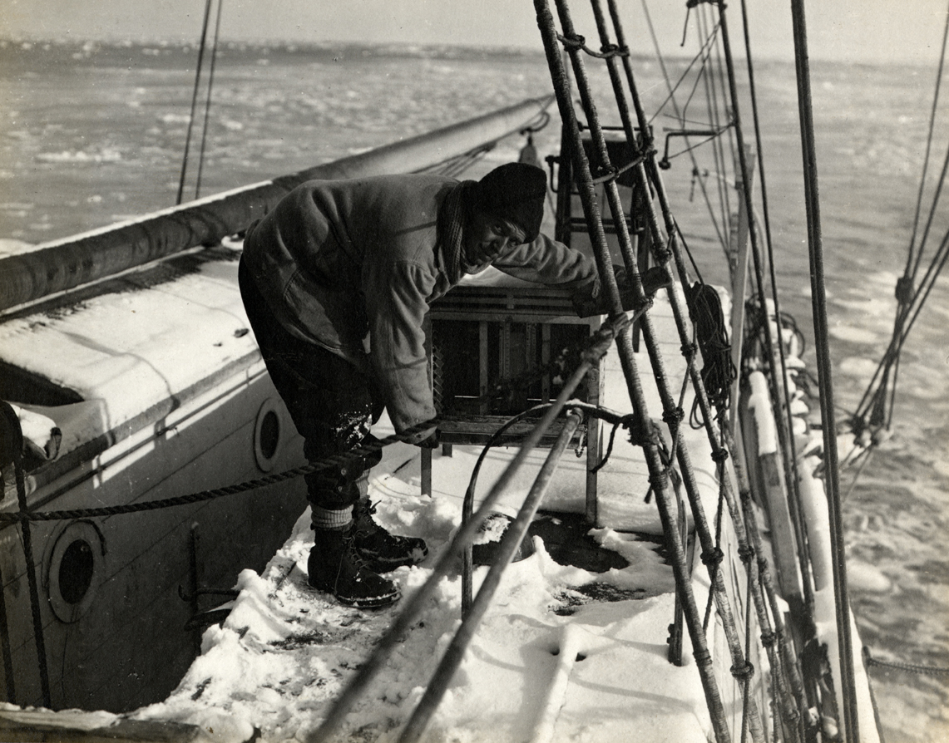
Taking meteorological observations © Royal Geographical Society (Ponting)

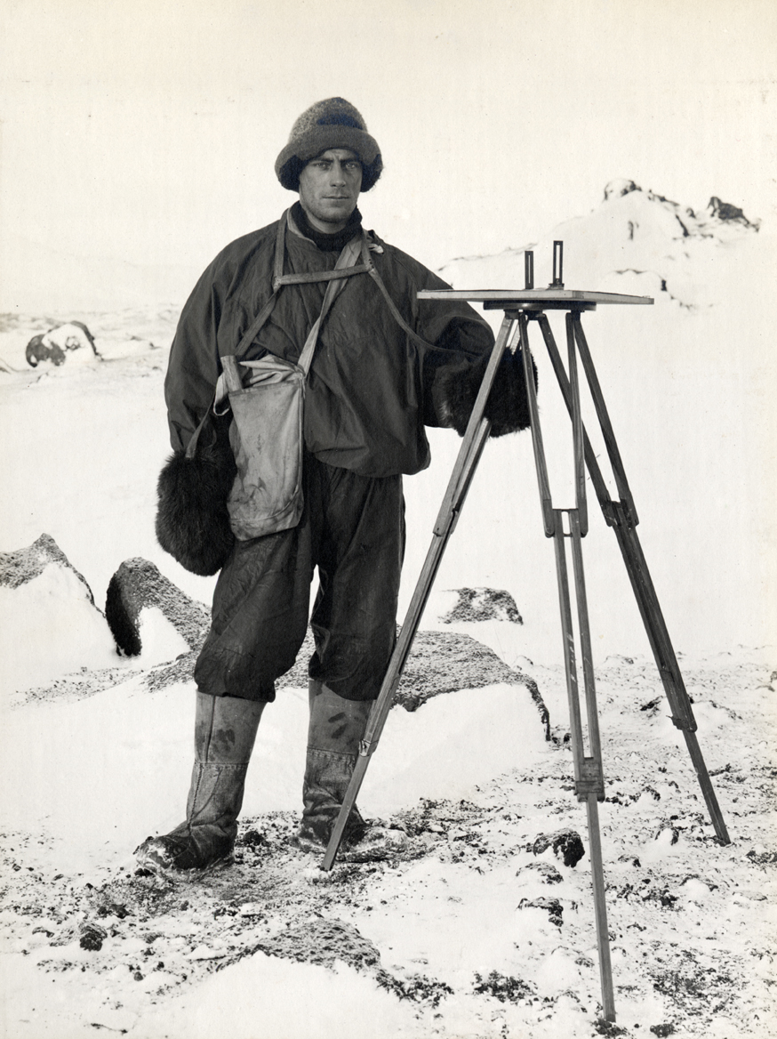
Geologist Frank Debenham surveying
© Royal Geographical Society (Ponting)

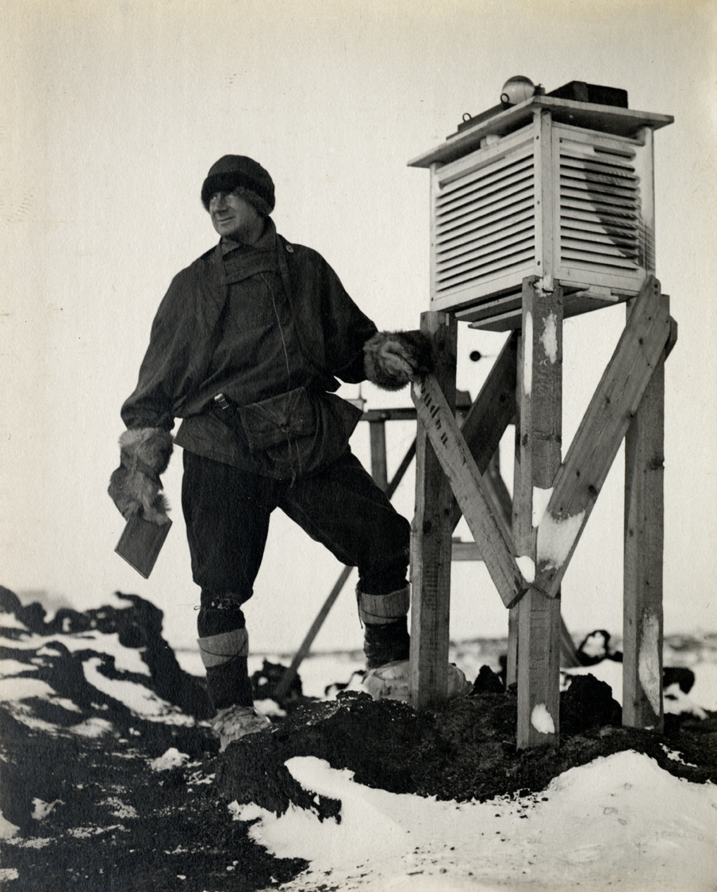
Recording sunshine © Royal Geographical Society (Ponting)

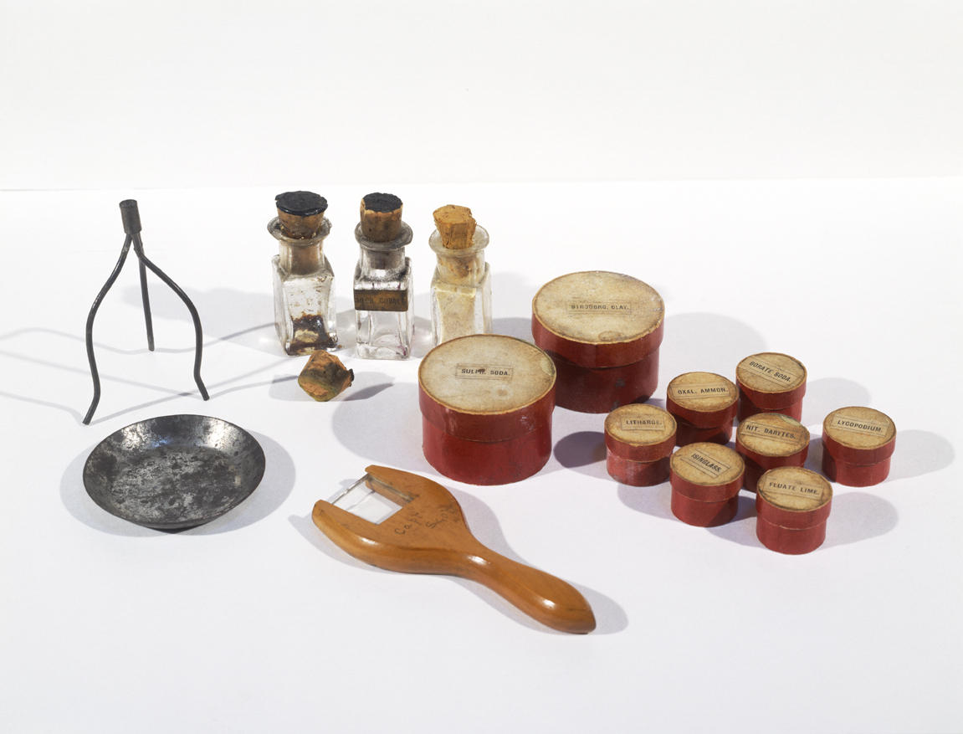
Scott’s chemistry set © Royal Geographical Society
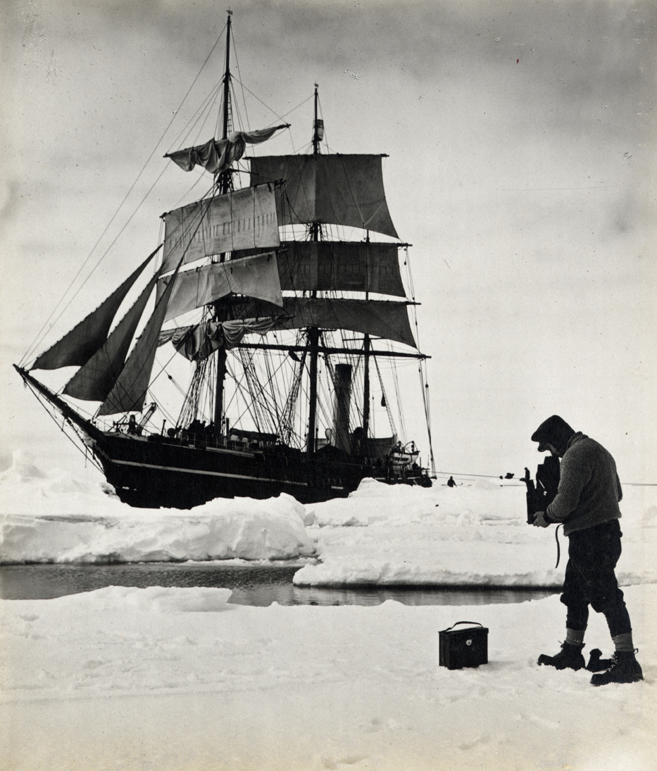
Ponting photographing the Terra Nova © Royal Geographical Society

1911
The first Japanese expedition led by Nobu Shirase landed at the Bay of Whales.

1911 – 1913
Wilhelm Filchner led an expedition on board the Deutschland to determine if Antarctica was a continent. He planned to cross Antarctica but failed. However the expedition did discover Luitpold Land and the Filschner Glacier.
1911 – 1914
Douglas Mawson led the Australian Antarctic Expedition aboard the Aurora the main aim of which was to investigate a stretch of essentially unknown Antarctic coastline and to undertake a scientific programme which included an investigation of the ocean and its floor between Australia and Antarctica. The main base was at Cape Denison in Commonwealth Bay from which Mawson and two others set of to explore the far eastern area of their survey. Despite atrocious weather with winds averaging over 60mph much new information was discovered and new lands surveyed. It was also the first time radio was used in Antarctica.

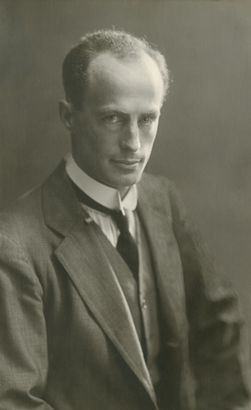
Douglas Mawson awarded the RGS Gold Medal in 1915 © Royal Geographical Society

1914 – 1916
Ernest Shackleton led the Imperial Trans – Antarctic Expedition aboard the Endurance. The aim of the expedition was to cross Antarctica from sea to sea via the South Pole. It would be an historical event and would also contribute to scientific knowledge as over half of the 1,800 mile journey would be over unexplored territory.
The Trans-Continental party would not be able to carry all their supplies so another group would be based on the Ross Ice Shelf laying depots towards the Beardmore glacier. Glacial and geological studies would take place both on the journey and by scientists at the bases. The Endurance carrying Shackleton’s party became stuck in the ice and nine months later eventually sank.
The men were marooned until the ice broke up enough for them to get to Elephant Island where Shackleton, along with Worsley, Crean, McNeish, McCarthy and Vincent set sail in the James Caird, one of the lifeboats from the Endurance, to seek the rescue of all of the men. The boat sailed through mountainous seas in gale force winds and eventually reached South Georgia.
The boat was not sea worthy enough to sail to the whaling station in the north of the island so Shackleton, Worsley and Crean set off to cross the island on foot over mountains and glaciers for 36 hours to the whaling station from which a rescue could be mounted.
More information can be found at http://www.unlockingthearchives.rgs.org/themes/antarctica/default.aspx

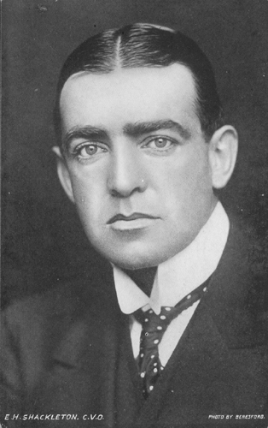
Ernest Shackleton © Royal Geographical Society

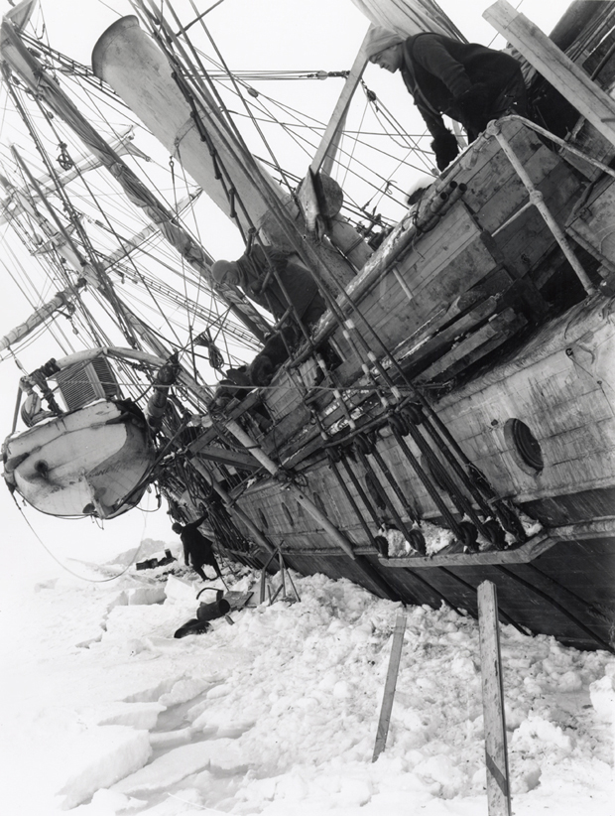
Endurance listing badly October 1915 © Royal Geographical Society
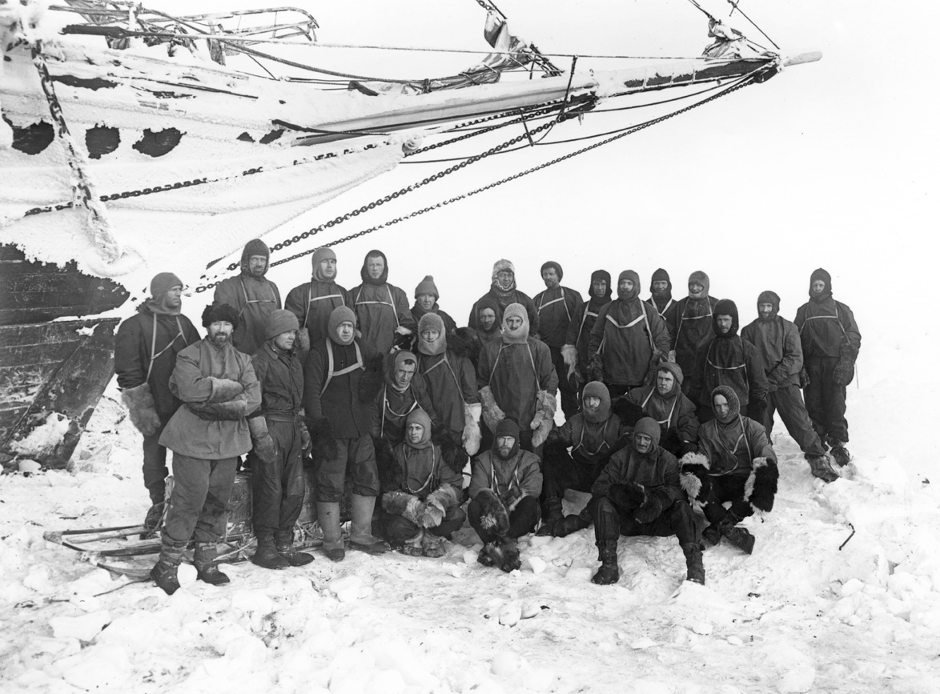
The crew of the Endurance on the ice © Royal Geographical Society

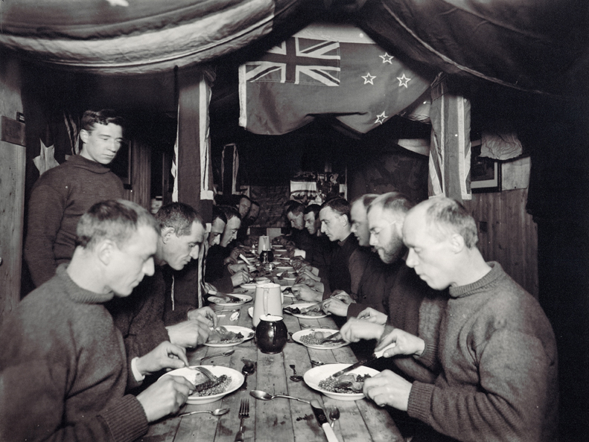
Midwinter dinner on board the Endurance © Royal Geographical Society
1914 – 1917
Ross Sea Party led by Aeneas Mackintosh on board the Aurora had the task of setting supply depots from McMurdo Sound to the Beardmore Glacier to provide supplies for the Trans – continental party led by Shackleton. Most of their supplies were on the ship and when she broke free and drifted away from Antarctica they were marooned, they survived by using supplies left in the hut by the Scott expedition in 1912. Despite this, atrocious weather and illness caused by poor diet they continued with the task of depot setting. They covered 1356 miles in six and a half weeks carrying some 4500lb of supplies, one of the longest land journeys undertaken to date. Before the group was rescued by the refitted Aurora in a relief operation planned by the RGS three of the party had died including Mackintosh. Shackleton provided an epitaph ‘Things done for gain are not, but good things done endure’.

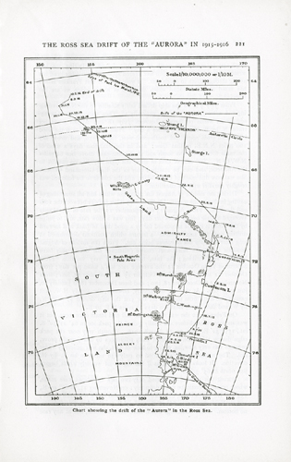
The drift of the Aurora © Royal Geographical Society
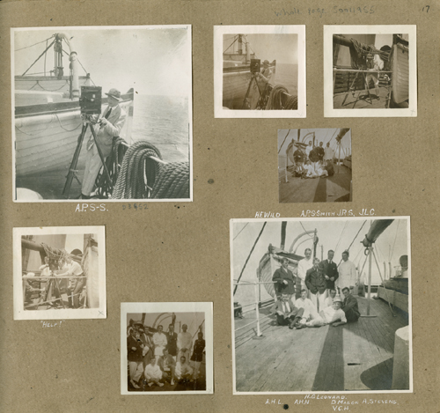
Members of the Ross Sea Party from an album by Ninnis © Royal Geographical Society

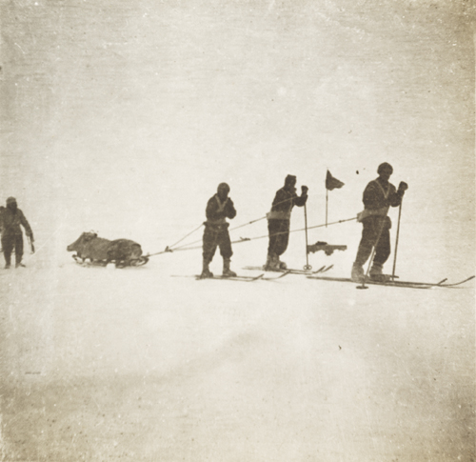
Men returning from laying a depot © Royal Geographical Society

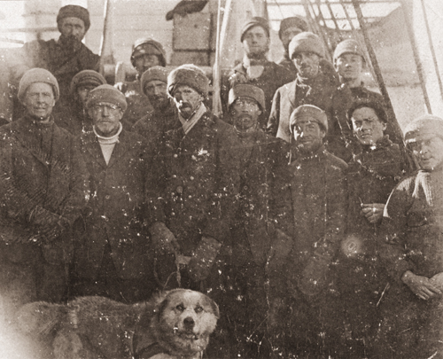
Shackleton and team members from the Aurora
© Royal Geographical Society
1920 – 1922
British Expedition to Graham Land led by John Cope planned an ambitious expedition to circumnavigate Antarctica and undertake the first flight over the South Pole. Funding was difficult so a small four man party set out. Eventually two men, Bagshawe and Lester were left in Antarctica to over winter, their shelter being a converted waterboat in Paradise Harbour, now renamed Waterboat Point. They undertook meteorological and zoological observations and collected data for a whole year for the first time.
1929 – 31
Douglas Mawson led the British, Australian and New Zealand Antarctic Research Expedition, or BANZARE for short, on board the Discovery.
A transcript of part of a 1993 video of Evelyn Forbes, daughter of Hartley Travers Ferrar the expedition geologist, talking about meeting Mawson on board the Discovery in New Zealand.
‘That was very exciting…Discovery was in Wellington and was there for a very short time. but Father was absolutely so thrilled and quite bemused too because Discovery had been changed so much inside he couldn’t find his lab or his little rabbit hole of a cabin and everything was strange. What was also so nice was that young Colbeck was there, Captain Colbeck’s son and Father was delighted to see him I think those were the only contacts with the Discovery or the Terra Nova.’
SPRI Oral History Project

The first flight had been flown over Antarctica in 1928. Extensive aerial reconnaissance and surveys from the ship by this expedition added to the knowledge of the Antarctic coastline and interior. A new age of Antarctic exploration had arrived using new technologies and equipment with an emphasis on research.
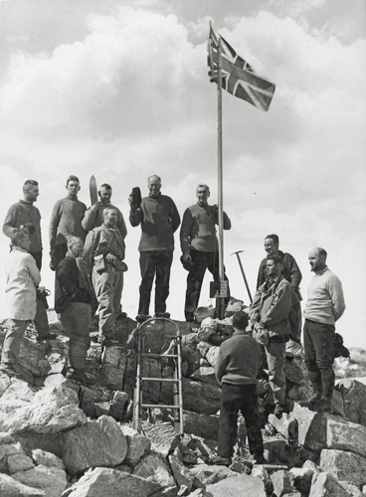
Hoisting the flag on King George Land, January 5th, 1931 © Royal Geographical Society
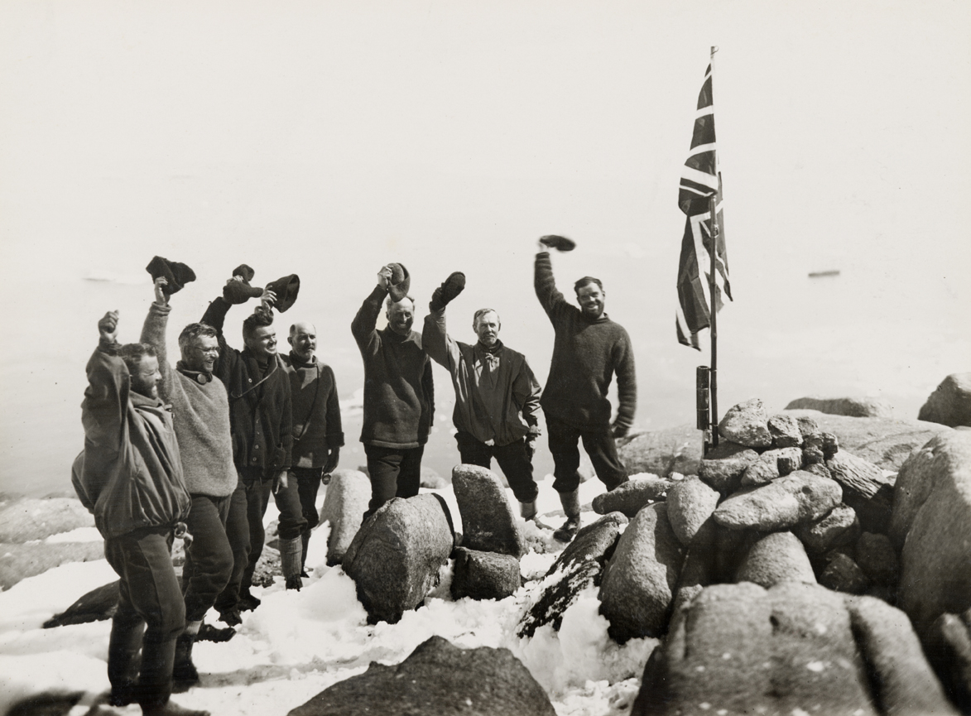
Cheering the flag on the summit of Proclamation Island, 13th January 1930. © Royal Geographical Society.
1934 – 37
British Graham Land Expedition led by John Rymill aboard the Penola with the aim of undertaking scientific research, assessing the economic potential of the area and reasserting British sovereignty in the Antarctic Peninsula. Funding came from the British government, the RGS and SPRI endorsed the expedition.
Transcript of part of a 2000 video of Colin Betram (1911 – 2000), polar biologist, Director of SPRI 1949-1956, member of the 1934-37 British Graham Land Expedition talking about how he became involved with the expedition.

‘I was beginning to get to know the Polar Institute and John Rymill was looking round when he decided he must go to the Antarctic. You must remember Gino Watkins had been trying to get a party to the South and he couldn’t but John Rymill, the Australian, he started again and began to get some success and he was looking around for some peoplpe at the Polar Institute where I happened to be at the time.’
SPRI Oral History Project

The Northern Base was set up on the Argentine Islands off the coast of the Antarctic Peninsula which were of exceptional biological interest. The party then moved south mapping and surveying the coast and setting up the Southern Base in the Debenham Islands where they made preparations to travel inland during the summer months in George VI Sound looking for a route to the Weddell Sea and undertaking geological investigations. Their research proved that the area was a peninsula and not an archipelago of islands as had previously been thought. More information can be found at www.spri.cam.ac.uk/resources/expeditions/bgl/

1935
In 1935 Caroline Mikkelsen, wife of a Norwegian whaling captain, became the first known woman to set foot, briefly, in Antarctica.

