Developing Understanding Timeline
Part one: 1772 - 1900

It is difficult to make a complete and detailed timeline of the major Antarctic expeditions as there have been over 300 of these since Antarctica was sighted for the first time. More details of the journeys below and some of the others can be found at www.south-pole.com.
- What was the main purpose of each expedition - exploration, research or both?
- Have the objectives of these visits changed over time?
Use the information on this sheet and parts 2 and 3 to answer the questions above. You could present your findings in the form of a table.

1772-5
Captain Cook and his crew became the first people to cross the Antarctic Circle and continued to 71˚ 10’S.

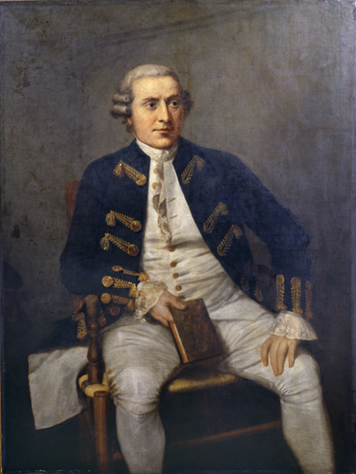
Captain Cook © Royal Geographical Society

1820
Fabian Bellinghausen (Russian) sighted Antarctica for the first time.

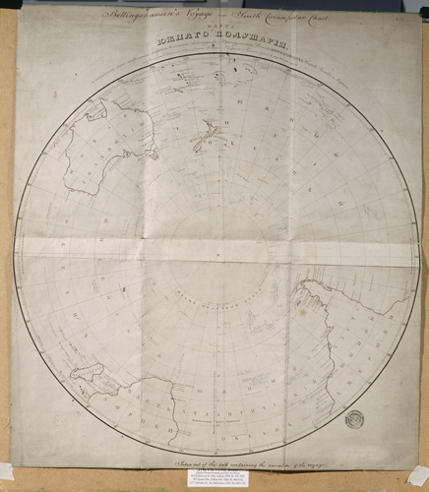
Bellinghausen's voyage - South Circumpolar Chart © Royal Geographical Society

1820 – 21
Edward Bransfield and William Smith saw the Antarctic Peninsula.

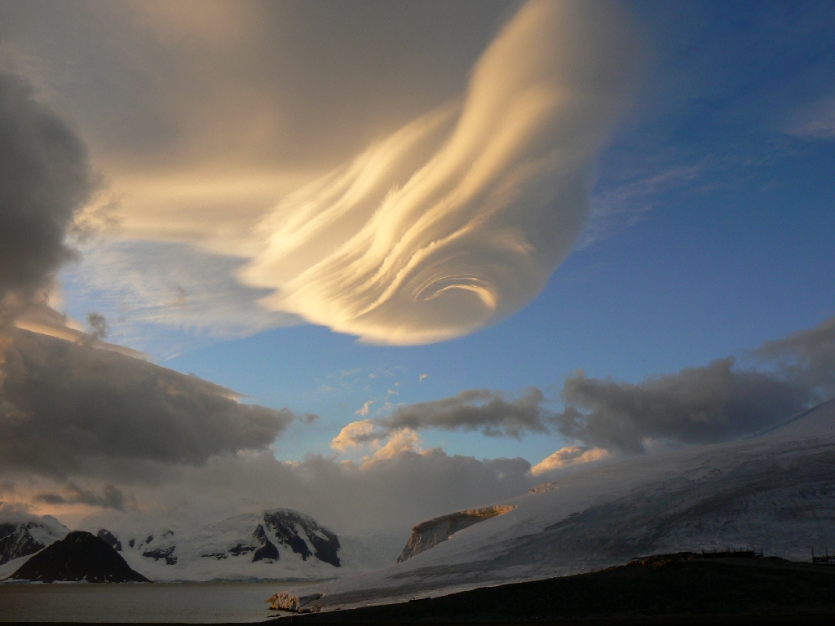
Cloud formation as seen from Rothera Research Station on the Antarctic Peninsula © British Antarctic Survey, Gavin Burns

1822
Captain James Weddell sailed to 74˚ 15’S found the Weddell Ice Sheet and Sea.

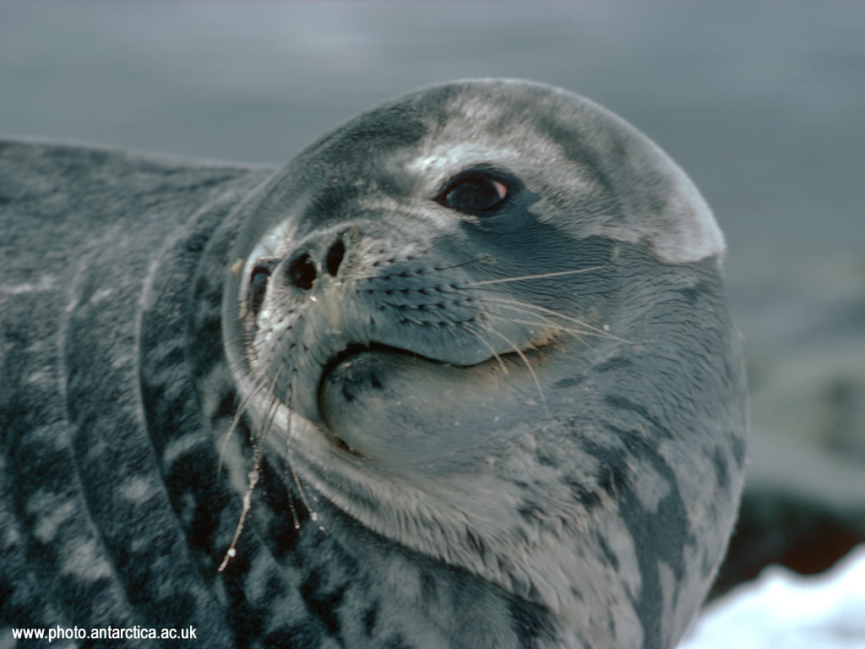
Weddell Seal

1828 – 31
Henry Foster found Deception Island

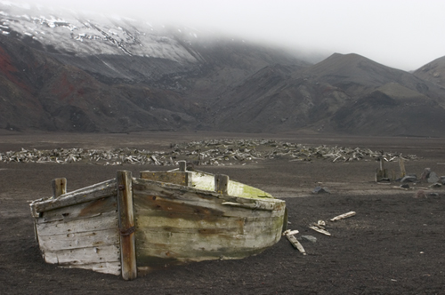
Water boat on Deception Island, Antarctic Peninsula © Carole Rawlinson, Royal Geographical Society

1830 – 32
John Biscoe found islands around Graham Land.

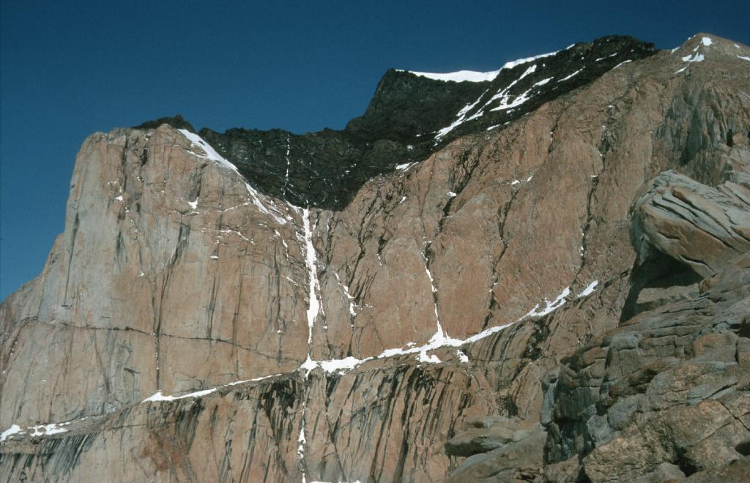
Graham Land © British Antarctic Survey, Philip Leat

1839 – 43
Captain James Clark Ross discovered the coast of Victoria Land, sighted Mount Erebus and found the Ross Sea and Ice Shelf.

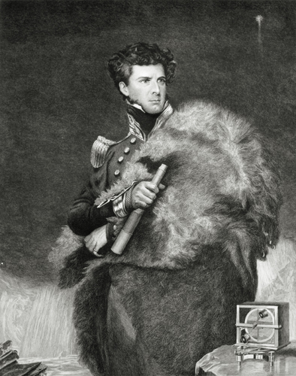
© Royal Geographical Society

1840
Frenchman Jules-Sebastian Dumont d’Urville discovered Adélie Land
1840
Lt Charles Wilkes of the United States Exploring Expedition sighted Wilkes Land.
1872 – 76
Charles Wyville Thompson studied the ocean depths.
1873
The German Eduard Dallmann discovered new Antarctic routes and his ship the Grönland became the first sailing ship with auxiliary steam to reach the Antarctic Peninsula.
1892 – 1894
Captain Carl Larsen of the Jason led a Norwegian expedition and became the first person to find fossils in Antarctica. He was also the first person to ski on an ice shelf in Antarctica which is now named after him.

1893
Captain Thomas Robertson of the Active, a steam powered vessel which was part of the Dundee fleet, discovered Dundee Island at the tip of the Antarctic Peninsula.
1897 – 1899
Adrien de Gerlache led the Belgian Antarctic expedition aboard the Belgica. The ship became stuck in the ice and the crew became the first people to survive overwintering in the Antarctic region.
1898 – 1900
Carsten Borchgrevink, a Norwegian, led the British Antarctic Expedition, funded by an English publisher. It was the first to overwinter on the Antarctic mainland at Cape Adare. The prime purpose was to determine the magnetic South Pole. They also surveyed the coast of Robertson Bay and collected specimens of birds, fish seals and penguins. They were the first to use dogs to transport them.
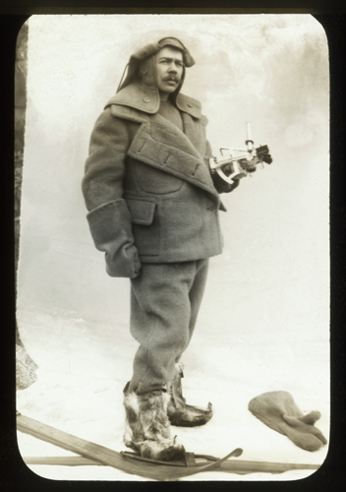
Borchgrevink © Royal Geographical Society

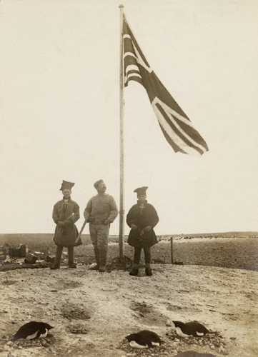
The flag at Cape Adare © Royal Geographical Society
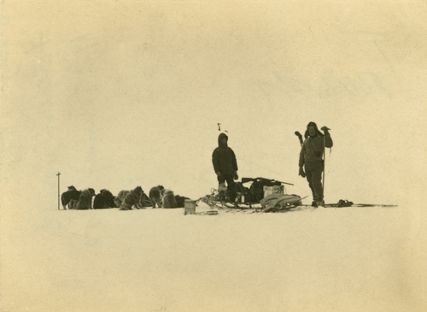
Sledge and dogs farthest south ©
Royal Geographical Society

