Prepare to travel south
To get to the remote parts of Antarctica and collect important scientific data, you can’t just book a flight, pack your scarf and gloves and head south! Antarctica is an extreme and hostile place and you’ll need to prepare carefully, have specialist training and make sure you’ve got all your cold-weather clothing and equipment packed. The British Antarctic Survey has been taking scientists and support staff to the frozen continent for over 50 years – once you’ve joined the Survey you can start the rigorous preparation process and become one of a select group to venture far into this remarkable, unique and scientifically important icy wilderness.

Get ready!
Follow the timeline below and learn about what it takes to get all the way to Rothera Research Station in the Antarctic Peninsula. You’ll need to think of everything before you’re allowed to venture out to collect your data as a fully-fledged Antarctic scientist.
Click here for more information about the journey south with the British Antarctic Survey.
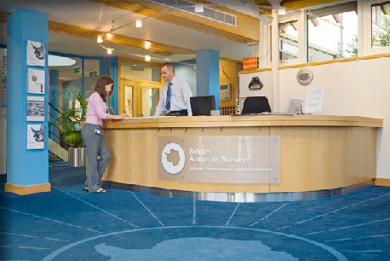

1. Congratulations!
You’ve got the job! You’re ready to start preparing to travel south – you need to get yourself checked out, learn new skills and pack carefully. You’re on the way to becoming an Antarctic scientist!
QVR movie of reception at the British Antarctic Survey


2. Medical
It’s important to make sure you’re in top condition before venturing out into the Antarctic wilderness. Every employee has an extensive medical with one of the BAS Medical Unit doctors. Although there will be a doctor on station when you get to Antarctica, it’s very important to make sure there are no serious medical conditions that could cause a problem when you’re thousands of miles from the nearest hospital!


3. Dentist
The last thing you want in Antarctica is tooth-ache! Teeth problems can be really serious if you’re going south for a long time with no dentists to help with fillings or extractions. Everyone needs a thorough check-up before you go.
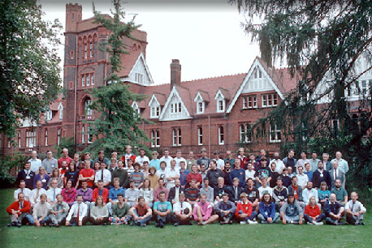

4. Conference
Every year, BAS has a 10-day briefing conference in Cambridge for all staff who are heading south. This intensive introduction to every aspect of living and working in Antarctica is vital for all new recruits. The conference also gives you a chance to meet the people you will be going south with and get to know each other.
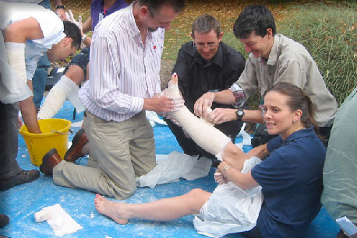

5. First aid training
Everyone completes a comprehensive first-aid course. If you’re out in the field and your colleague breaks their leg, you have to be the paramedic, doctor and nurse! The course covers every element of first-aid and leaves you ready to cope with even the most serious situation.
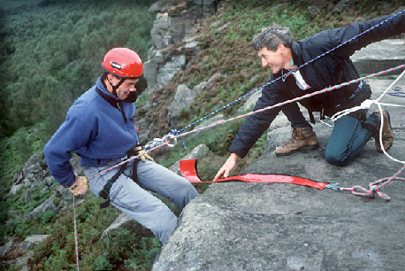

6. Field training
It’s time for more training! You’ll head to the wilds of Derbyshire for three days of field training, including camping, abseiling, rope work and other skills vital for travelling around Antarctica.
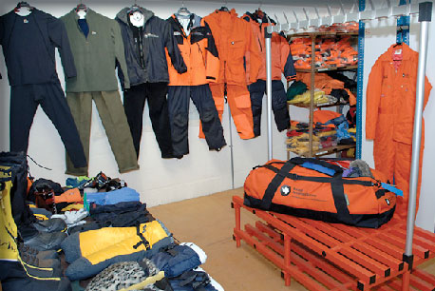

7. Clothing
You’re nearly there – now it’s time to get all your clothing and equipment issued. A visit to the BAS clothing store means your kit bag can be filled with thermals, jackets, boots, gloves, water bottles, sunglasses and all the other things you’ll need. Your kit bag gets loaded onto one of the BAS ships and meets you there!
QVR movie of the clothing store at the British Antarctic Survey


8. Injections
Although there are no diseases or illnesses native to Antarctica because of the extreme cold, you will need to get your yellow fever jab. This is because there is a small chance that your military flight to the Falkland Islands may get diverted to West Africa – an active yellow fever zone.
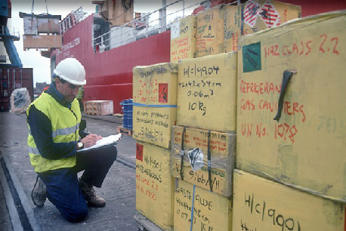

9. Packing
Before the ship sails, you must pack all the scientific equipment required for your time in the Antarctic. The ship takes nearly 40 days to reach Rothera Research Station – you’ll rendezvous with it in the Falkland Islands later on.
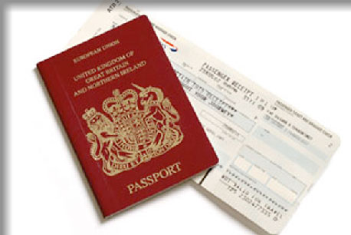

10. Passport and tickets
It’s time to go! Make sure you’ve packed your personal belongings and have got your all-important passport and tickets. With your training complete and equipment packed, it’s off to the airport so your Antarctic adventure can begin.
The journey

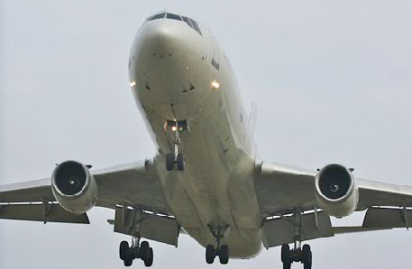

Flight from R.A.F. Brize Norton to Ascension Island
Distance: 4,200 miles (6,700km)
Length of time: 9 hours 30 minutes
Your journey starts with a coach ride to R.A.F. Brize Norton in Oxfordshire. From here you board a military Boeing 767 charter flight to Ascension Island in the middle of the South Atlantic, where you’ll stop to refuel.
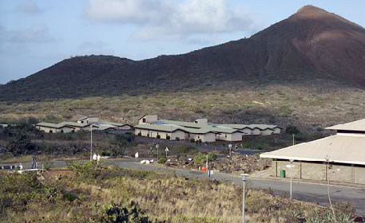

Ascension Island
Ascension Island lies almost exactly on the equator and you’ll notice the heat when you step off the plane. You will spend a couple of hours at Wideawake airfield before getting back on the aircraft for the second leg of your journey to the Falkland Islands.
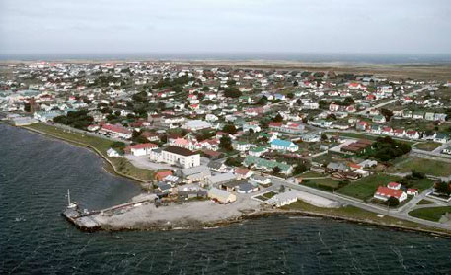

Flight from Ascension Island to the Falkland Islands
Distance: 3,400 miles (5,500km)
Length of time: 8 hours
This leg of the journey sees you cross the equator and fly across the South Atlantic to Mount Pleasant airfield in the Falkland Islands. From there you’ll get driven into the capital, Stanley, where you can rest for the night.
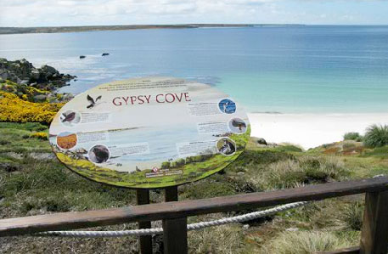

Falkland Islands
You’ll usually get a day or two to explore this part of the Falklands and there’s plenty to see – shipwrecks, beautiful beaches, penguins, amazing birdlife and plenty more. You’ll need some luck with the weather though as it’s notoriously changeable in this part of the world!
QVR movie of Stanley, capital of the Falkland Islands
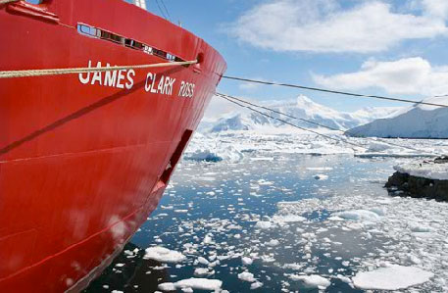

Ship from Falkland Islands to Rothera Research Station
Distance: 1,100 nautical miles (1,750km)
Length of time: 4 days
BAS’s ice-strengthened research ship RRS James Clark Ross will depart from Mare Harbour on its four-day journey to Rothera Research Station in the Antarctic Peninsula. Get your sea legs quickly, as you’ll head straight out into the Drake Passage – the roughest bit of ocean on the planet! Once across, the magnificence of Antarctica will make it all worthwhile. It’s one of the most memorable journeys you’re ever likely to make.
QVR movie of the Bridge on RRS James Clark Ross

You've arrived!

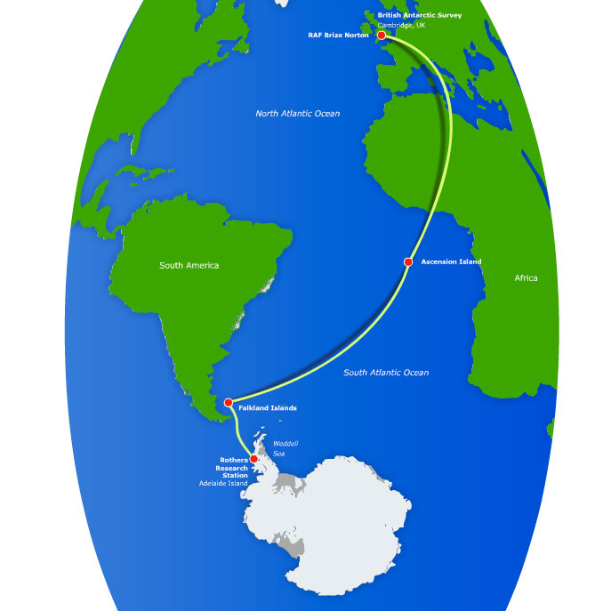

Now you’ve made it all the way to Rothera, move on to the GO WITH THE FLOE activities to start collecting your Antarctic data!”

