Breaking the ice:

International co-operation in Antarctica
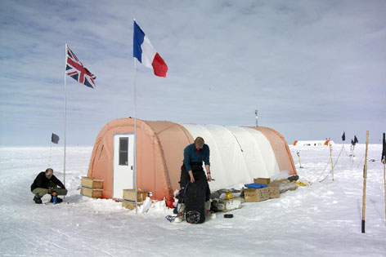
The Treaty was negotiated in the late 1950s, as competing territorial claims by different countries for slices of Antarctica were a source of international conflict. As well as the seven countries that claimed Antarctic territory, the USA and the Soviet Union also made it clear that they would claim territory too if they so wished.
Thankfully, co-operation between scientists from twelve different countries eased some of this international tension, and encouraged them to look for a lasting solution to protect Antarctica’s future. During the ‘International Geophysical Year’ from 1957-1958, scientists from Argentina, Australia, Belgium, Chile, France, Japan, New Zealand, Norway, South Africa, UK, USA and former Soviet Union worked together to set up permanent research stations in Antarctica. They also shared ideas in their research, which changed our understanding of the continent and how important it is to all of us.
The tremendous success of the ‘International Geophysical Year’ led to the Antarctic Treaty, signed by representatives of all twelve countries involved on 1 December 1959. Since then, helping out others and sharing scientific information has become the norm in Antarctica, and a special spirit of camaraderie binds those who work there - no matter where they come from.
UK scientists have successfully collaborated in projects with Belgium, Denmark, France, Germany, Italy, The Netherlands, Norway, Sweden, Switzerland, Australia, the USA, New Zealand, Japan, Russia and South Africa. If there is a life-threatening situation at an Antarctic research station or a ship runs into trouble in the ice, people based at other research stations will do what they can to help. There have been many occasions where victims of serious injuries have been airlifted out of Antarctica to receive medical treatment elsewhere in planes owned and piloted by other countries.
Scientists also mix socially with international colleagues, either by radio or by organising friendly visits to neighbouring research stations.
Most meetings are during scientific collaborations, as one country’s scientists may use another’s station as a base for its research, or several countries may set up a joint field camp for an Antarctic summer season. During its current five-year science programme, the British Antarctic Survey will complete many major international collaborative projects. A recent example is the successful surveying of the Pine Island and Thwaites Glacier basins underneath the West Antarctic Ice Sheet, which was a joint UK/US project.

Visit www.guardian.co.uk/flash/0,5860,1080359,00.html
to find out more.

