Who’s eating who?
Can you complete the Antarctica food web by putting the creatures in the correct places?
Phytoplankton are at the bottom of the chain. We’ve put them in already to start you off!
Print these pages, then cut out the small pictures below and fit them onto the diagram which is on the last page.

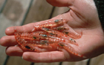
Antarctic Krill:
these small shrimp-like crustaceans feed on the phytoplankton.

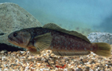
Fish:
most of the species of fish in Antarctica feed on krill, and are eaten by penguins, seals, sea birds and squid.

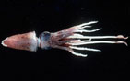
Squid:
there are 18 different species in Antarctic waters. They feed on small fish and krill, and are eaten by whales, seals and sea birds.

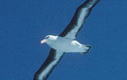
Sea birds:
sea birds, such as albatross and petrels, are scavengers in the sky. They swoop down to catch fish or squid near the water’s surface.

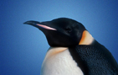
Penguins:
there are six species of penguin in Antarctica. They feed on fish and krill, but are a favourite food for killer whales and seals.

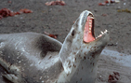
Leopard Seal:
one of the six species of seal in Antarctica, leopard seals usually hunt alone, feeding on penguins, young crabeater seals, fish, squid and krill.

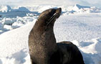
Crabeater Seal:
they feed on Antarctic krill (not crabs!), and collectively may even eat more krill than blue whales. Crabeater seals are a tasty meal for Leopard Seals when they are young, and killer whales are a danger no matter how old they are.

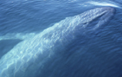
Blue Whale:
they feed on a lot of krill – up to 3 tonnes in a single meal! Their only potential danger is the killer whale.

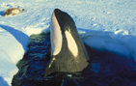
Killer Whale:
travelling in family ‘pods’, killer whales feed on seals, penguins and fish near the water’s surface. Occasionally they hunt other types of whale.
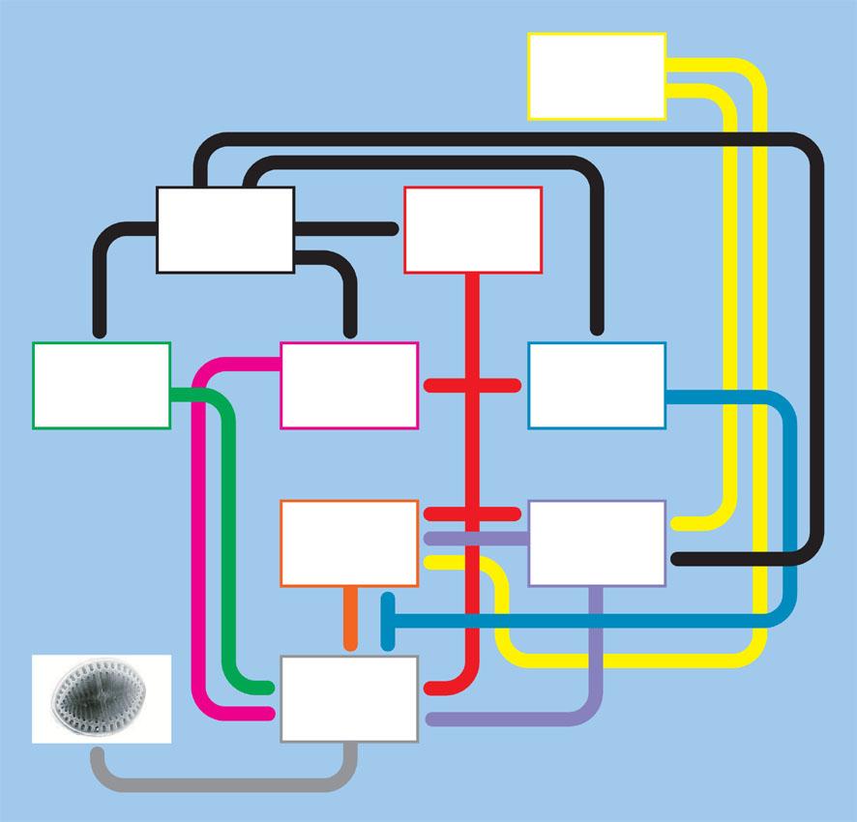

Who are the vegetarians?
Who are the carnivores?
And which predator is top of the food chain?

