Rothera research station
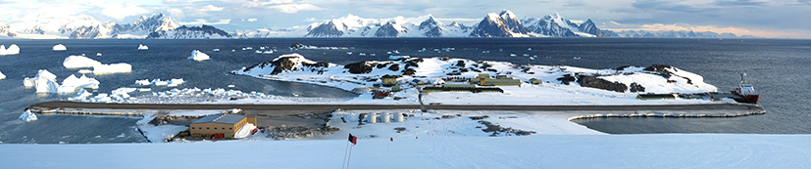
The view looking East, across Rothera Research Station, towards the Antarctic Peninsula as seen from the top of 'the ramp' above the station. This image shows the whole of the research station from the Hangar (lower left) to the wharf where you can see the BAS ship the RRS James Clark Ross (on the right) © British Antarctic Survey, Pete Bucktrout
The station is located on Adelaide Island and is named after John Rothera, a surveyor who explored the area known as Rothera Point with Peter Gibbs in 1957. Rothera station was established in 1975. The site continues to develop, not as an expansion but an ongoing programme of replacing old structures using new technologies to reduce the environmental footprint.
It is open throughout the year; in summer about 100 people are at the station in the winter this reduces to 22. People on the station on the station include marine & terrestrial biologists, meteorologists, electronics engineers, dive officer, boating officer, chef, doctor, vehicle and generator mechanics, electricians, plumbers, builders, field assistants, communications managers and of course a station management team. Most people arrive aboard a Dash 7 aircraft flying from either Stanley in the Falkland Islands or Punta Arenas in Chile. BAS ships visit Rothera at least twice a year docking at the Biscoe Wharf bringing cargo in containers as well as passengers.

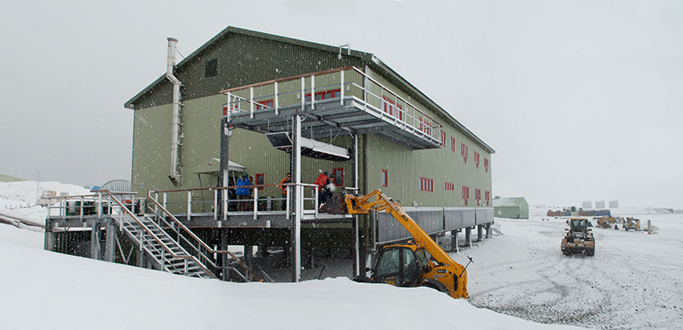
The new Bransfield House © British Antarctic Survey, Pete Bucktrout
Bransfield House provides dining, social and recreational facilities. It also houses offices and laboratories. Water supply is provided by converting sea water into fresh water which uses less energy than melting snow as was done in the past. A sewage treatment plant means that only cleaned water is discharged into the sea. Solids from the treatment plant are incinerated and the residual ash is removed from Antarctica by ship.

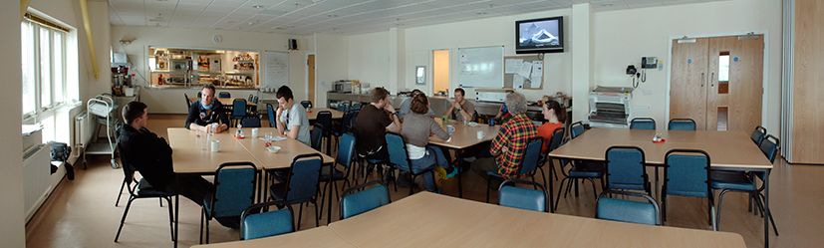
Dining area © British Antarctic Survey, Pete Bucktrout

Chef preparing food, ©British Antarctic Survey, Pete Bucktrout
Meals are taken communally in the dining room. Breakfast is self prepared cereal and toast; lunch and dinner are prepared by the chefs. On a Saturday evening there is a more formal dinner. Although there are not fresh ingredients every day the chefs prepare food of the highest standard.
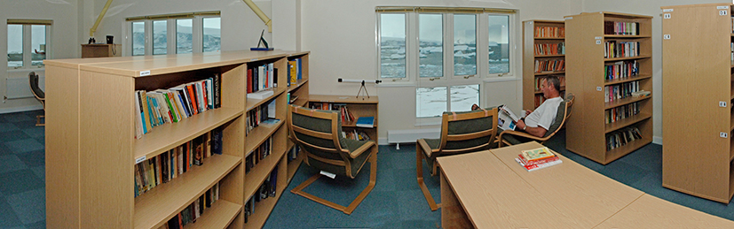
Library© British Antarctic Survey, Pete Bucktrout
There is always plenty of work to do on an Antarctic station, when the weather is bad there is work to do in the laboratories. When the weather is suitable for aircraft operations researchers go out into the field. Field work is concentrated in the summer months from November to March.
Field science programmes currently being supported from the station include glacial retreat, ice coring for the study of atmospheric chemistry and climate as well as the collection of geological data to support computer modelling of the historic movement of ice sheets. There is a considerable science programme being undertaken at the station itself. The Bonner Laboratory with its incorporated dive facility provides an excellent centre for the study of marine and terrestrial biology. The dive programme continues year round with divers accessing the water through holes cut in the sea ice during the winter.
Find out more about the research at Rothera in the ‘Collect Data’ section
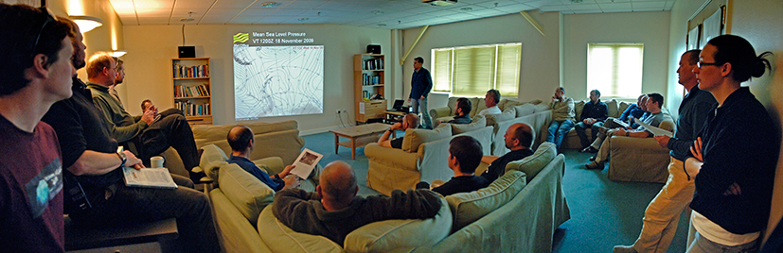
A met (Meteorology) briefing during the regular morning 'operations briefing' taking place in the coffee lounge of Bransfield House © British Antarctic Survey, Pete Bucktrout
In summer the temperatures are typically in the range 0 to +5 deg C, in winter they are more likely to be between –5 and – 20 deg C. Due to the coastal location and the track taken by southern ocean low pressure weather systems they can vary widely at any time of year. The prevailing wind direction is northerly. Gale force winds are usually recorded on seventy days per annum. Snow can fall at any time of year though in recently the main fall has come and the end of winter. It does occasionally rain at Rothera. Laying just south of the Antarctic Circle the station receives twenty four hour daylight in summer, and for a few weeks in winter the sun does not rise above the horizon at all.
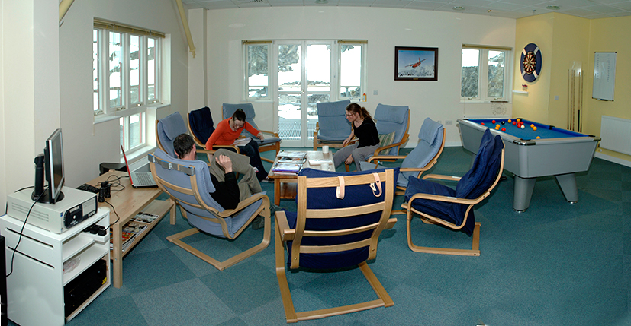
Lounge © British Antarctic Survey, Pete Bucktrout
The coastal location means that there is a wide variety of wildlife to observe. There are penguins, seals and whales as well as sea birds. Small numbers of minke and humpback whales are seen in Ryder Bay each summer, some years the minke is observed almost daily. A family of Orcas inhabit the larger Marguerite Bay area and are usually seen from the station several times each summer.
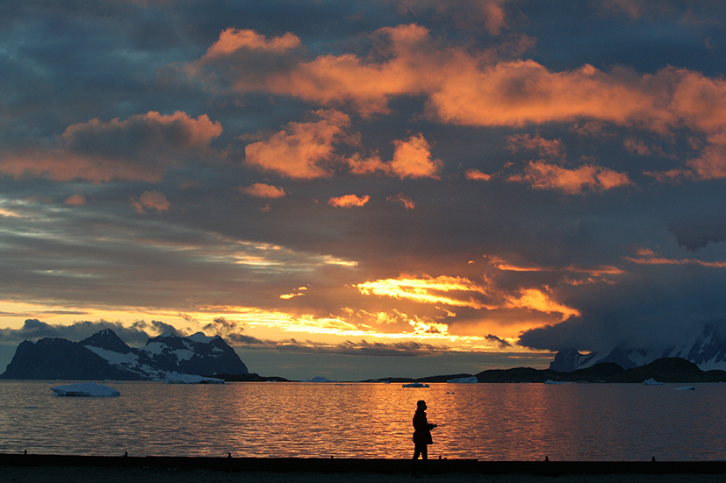
Sunset over Ryder Bay viewed from Rothera Research Station.
© British Antarctic Survey, Lloyd Peck

