The climate today
For some scientists, Antarctica is pretty much home - they live and work at Rothera Research Station all year round, and experience the changes through the seasons.
Look at the climate data for Rothera, and the diary extracts. Which months do you think they are talking about? Why?

Climate data
Rothera research station | Jan | Feb | Mar | Apr | May | Jun | Jul | Aug | Sep | Oct | Nov | Dec
Temperature (°C) | 0.8 | 0.4 | -2.2 | -4.0 | -4.9 | -11.7 | -10.9 | -9.9 | -6.5 | -3.2 | -1.0 | -1.2
Windspeed (km/hr) | 16.7 | 22.2 | 25.9 | 22.2 | 20.4 | 14.8 | 22.2 | 27.8 | 20.4 | 29.7 | 18.5 | 22.2

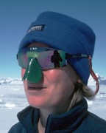
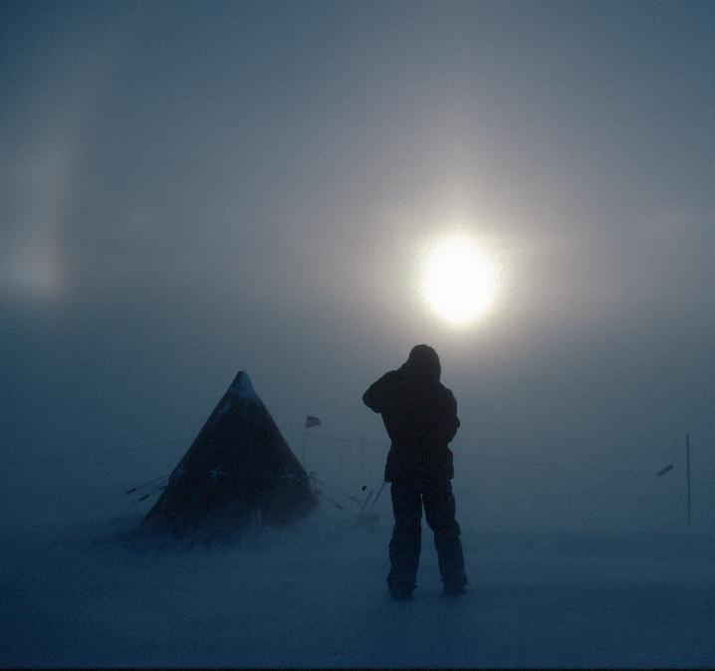
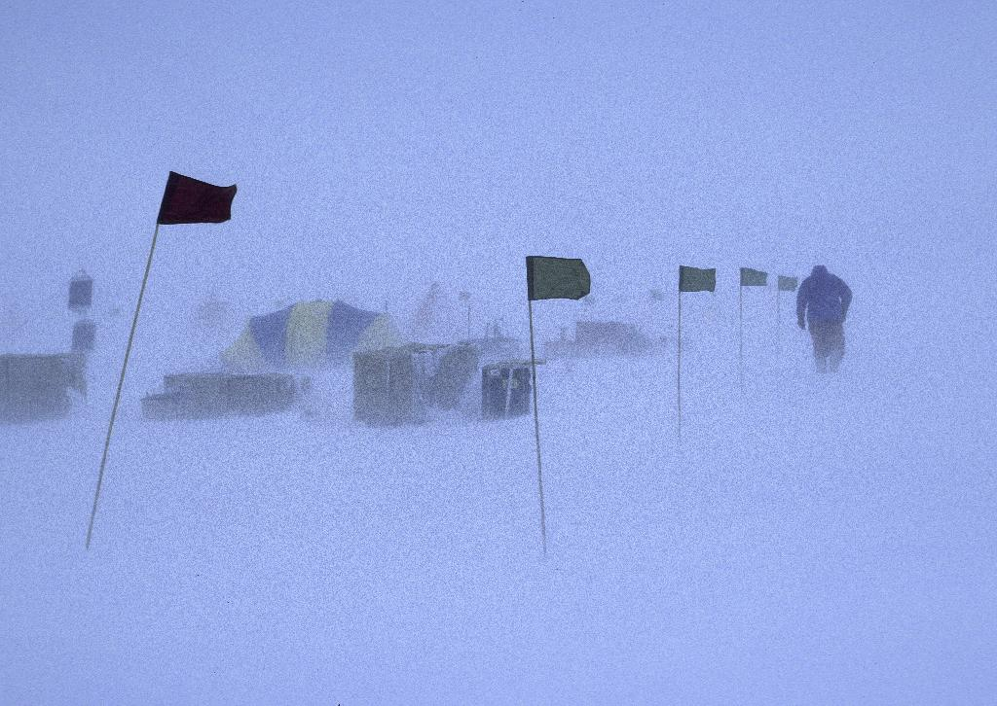
The solar panels and weather stations outside bang and clatter in the severe gales, so I haven’t got much sleep lately. Diving beneath the ice is one way to escape the wind, but once we’re back on the surface it doesn't take long for the bitter cold to freeze-mould our dry suits to our bodies.

There may be no trees here for leaves to fall off, but it’s getting colder and we are one step closer to winter. Those leaving soon are talking about the things they are going to do when they get home - have a pint of draught Guinness or go on holiday to a very hot, sunny place!

Days are now shorter, temperatures lower, snowfall heavier and most of the wildlife has left for warmer climes.
It’s the shortest and darkest day of the year. Tonight, the twenty of us still here are going to celebrate the winter solstice with a big party. Skiing on the sea-ice has been fun too - it is the closest thing to walking on water!

The weather is superb. Just imagine being here, sitting on the veranda, sun tan lotion and sunglasses on, watching seal pups playing together - how lucky are we!

